Student Learning and Licensure (SL&L) New Course-Based Activity/Assignment Assessment Tool
Please make a copy of this template, edit and fill in the missing pieces as needed, then send to Andy. Yellow shading shows example data – please overwrite with your information!
Course (EDSR/EDUA): 4321
Assignment / Activity Name: Lesson Planning
(Please note that SL&L uses meta-data: there is no need to have a place in your assessment tool to enter the student name, scorer name, submission date, etc. – this is all captured since log in is required to submit work or assessments in SL&L.)
Is a student submission required?
Yes (in this example, the student submits a lesson plan in Word or as a PDF)
No (this choice would be based on observation, either across a time period, or, as an example, an in-class presentation)
Your new assessment tool can have open-ended comment boxes for you to provide qualitative feedback to your students. These often are after the main scoring rubric, but can be placed anywhere you want to enter something.
Examples:
Strengths of Lesson Plan:
Text boxes are usually set to be optional for the scorer but can also be required.

Ideas to make it better:
Text boxes are usually set to be optional for the scorer but can also be required.

The main portion of your new assessment tool will likely be a Likert based rubric. You may have as many individual elements as you like, and also up to 10 scoring categories with associated points. Each element will also allow for an optional N/A response and optional individual comments, element by element. You may optionally have descriptors for each Likert level

This is a general example of what Andy needs (example is a submitted Lesson Plan).
 | 4 Points | 3 Points | 2 Points | 1 Point
Scoring Element | Exemplary | Proficient | Developing | Beginning | N/A | Comments
TEKS Learning Objectives | Objectives are specific, measurable, aligned with standards, and clearly guide all lesson components. | Objectives are clear and mostly measurable; generally aligned with lesson activities. | Objectives are vague or partially measurable; limited alignment with activities. | Objectives are unclear, missing, or not measurable / aligned. |  | Recommended but optional Likert descriptors
Instructional Design & Activities | Activities are engaging, logically sequenced, and strongly aligned to objectives; includes differentiation. | Activities are appropriate and mostly aligned; sequence is logical with some engagement. | Activities show partial alignment; sequence or engagement is inconsistent. | Activities are unclear, poorly sequenced, or not aligned to objectives.
Assessment & Evaluation | Individual element Likert level descriptors are optional but recommended. Here, the faculty would simply look at the element description and decide if the work is Exemplary, Proficient, etc. without descriptors. |  |  |  | Or you may leave these boxes blank
Content Knowledge & Accuracy
Clarity, Organization & Professionalism

If you are comfortable in Word, use Word. If you prefer Excel, use Excel.
Turn-around time for a work-up as it would appear in SL&L is usually 1-2 days. Deploying as an SL&L Activity can happen within 1 day, and Andy will handle this for you, including set up for direct linking in Blackboard – Andy will usually create an SL&L Specific Folder in your course section(s) in Blackboard, then add the SL&L submission link and other items as needed. After this, you are welcome to move the assignment anywhere in your Bb course.
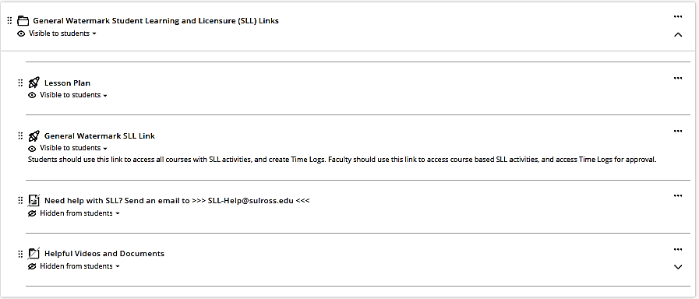
You may type in these boxes if you like or create your own!

Phrases entered will wrap around as needed

