JOIN THE CONNECTING WITH STUDENTS FOR SUCCESS RETENTION PROGRAM

WHAT
Starting Spring Semester 2024, the Provost’ s Office is funding the Connecting with Students for Success Program that already has proven success (see figure 2 below).
I am seeking 20 faculty members to join the Connecting with Students for Success program this spring.

Participating faculty agree to embed the four practices in one of their courses (see figure 1 below).

PROGRAM ACTIVITIES
- Participating faculty will select one of their courses for the program. Recommended course size should be between 8 to 20 students enrolled. Courses may be online or face-to-face. Courses may be undergraduate or graduate level. Courses for students graduating spring semester 2024 are discouraged, because we are tracking enrollment the following semester, and graduating students may not be continuing.
- Participating faculty will embed the logo (figure 1) below in their course syllabi and implement each of the four practices with their students.
3. Faculty will schedule an individual conference of 15 minutes or longer with each student in the course before midterm (March 18, 2024).
4. Faculty will receive a complimentary copy of Relationship-Rich Education and participate in group discussion of the book-----January 31, 2024, at 4:00 p.m. BAB 300 or online.
5 Faculty will receive a complimentary copy of Feedback Fundamentals and participate in group discussion of the book and share their own feedback data----March 6, 2024, at 4:00 p.m. BAB 300 or online.
6. Faculty will provide the CRN number of their course and encourage students in their classes to complete the Connecting with Students for Success survey launched April 15, 2024.
7. Faculty will complete the end of semester survey on their participation in the Connecting with Students for Success program.

BENEFITS OF PARTICIPATION
- Student retention increases. Data in Figure 2, show that overall students in the program in Fall 2022 had a higher retention rate in Spring 2023 (2.2%) than other students who were not in the program. Some levels, such as first year courses, had a 13.4% higher retention rate than students who were not in the program.
- Faculty who have participated in the Connecting with Students for success pilot report a high level of collegiality among the faculty members.
- Upon the completion of the semester activities, all participating faculty will receive a $500.00 stipend for each semester of participation.

JOIN NOW
All interested faculty are asked to complete the attached application and forward it to Jeanne Qvarnstrom before January 17, 2024. The Spring 2024 program is limited to 20 participating faculty. The program will begin on January 17 with all participating faculty inserting the logo below in their syllabi.

I look forward to coordinating this program with you for the benefit of our students and university.
Warm regards,
Jeanne

Figure 1: Logo featuring the four practices to place in course syllabus

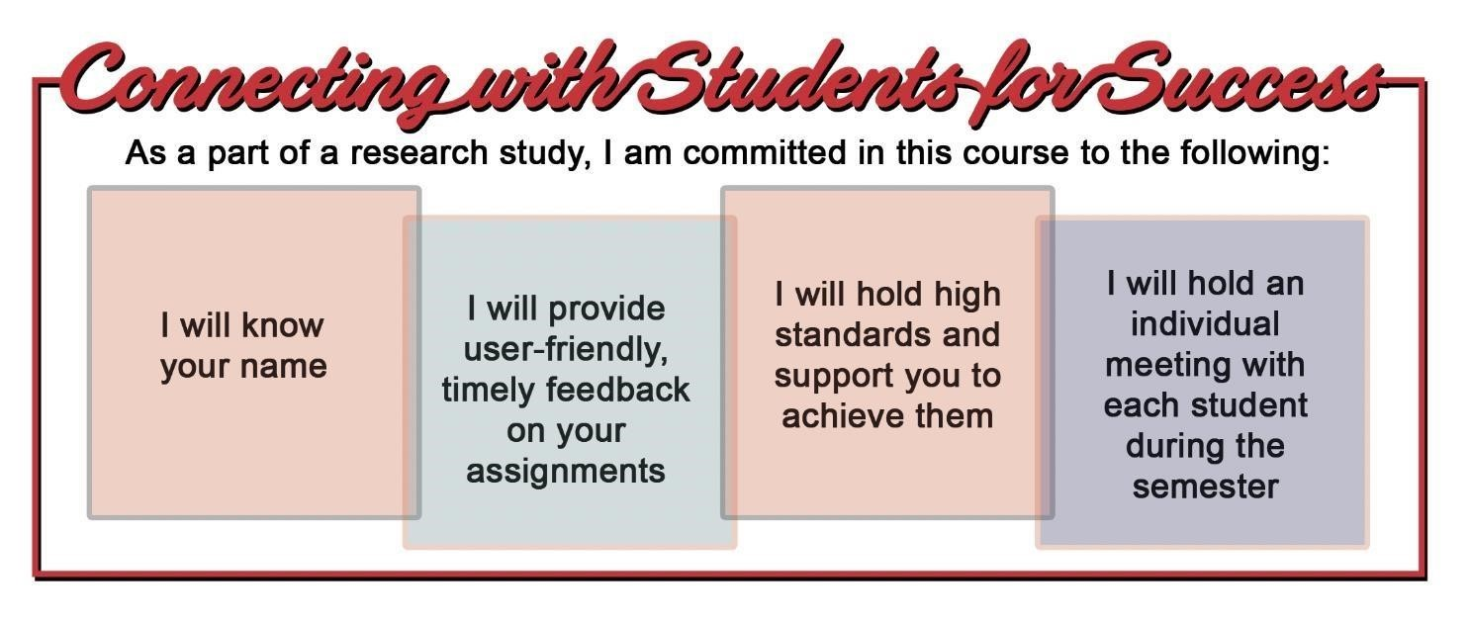
Figure 2: Documented Retention Program Success from Fall 2022 to Spring 2023

