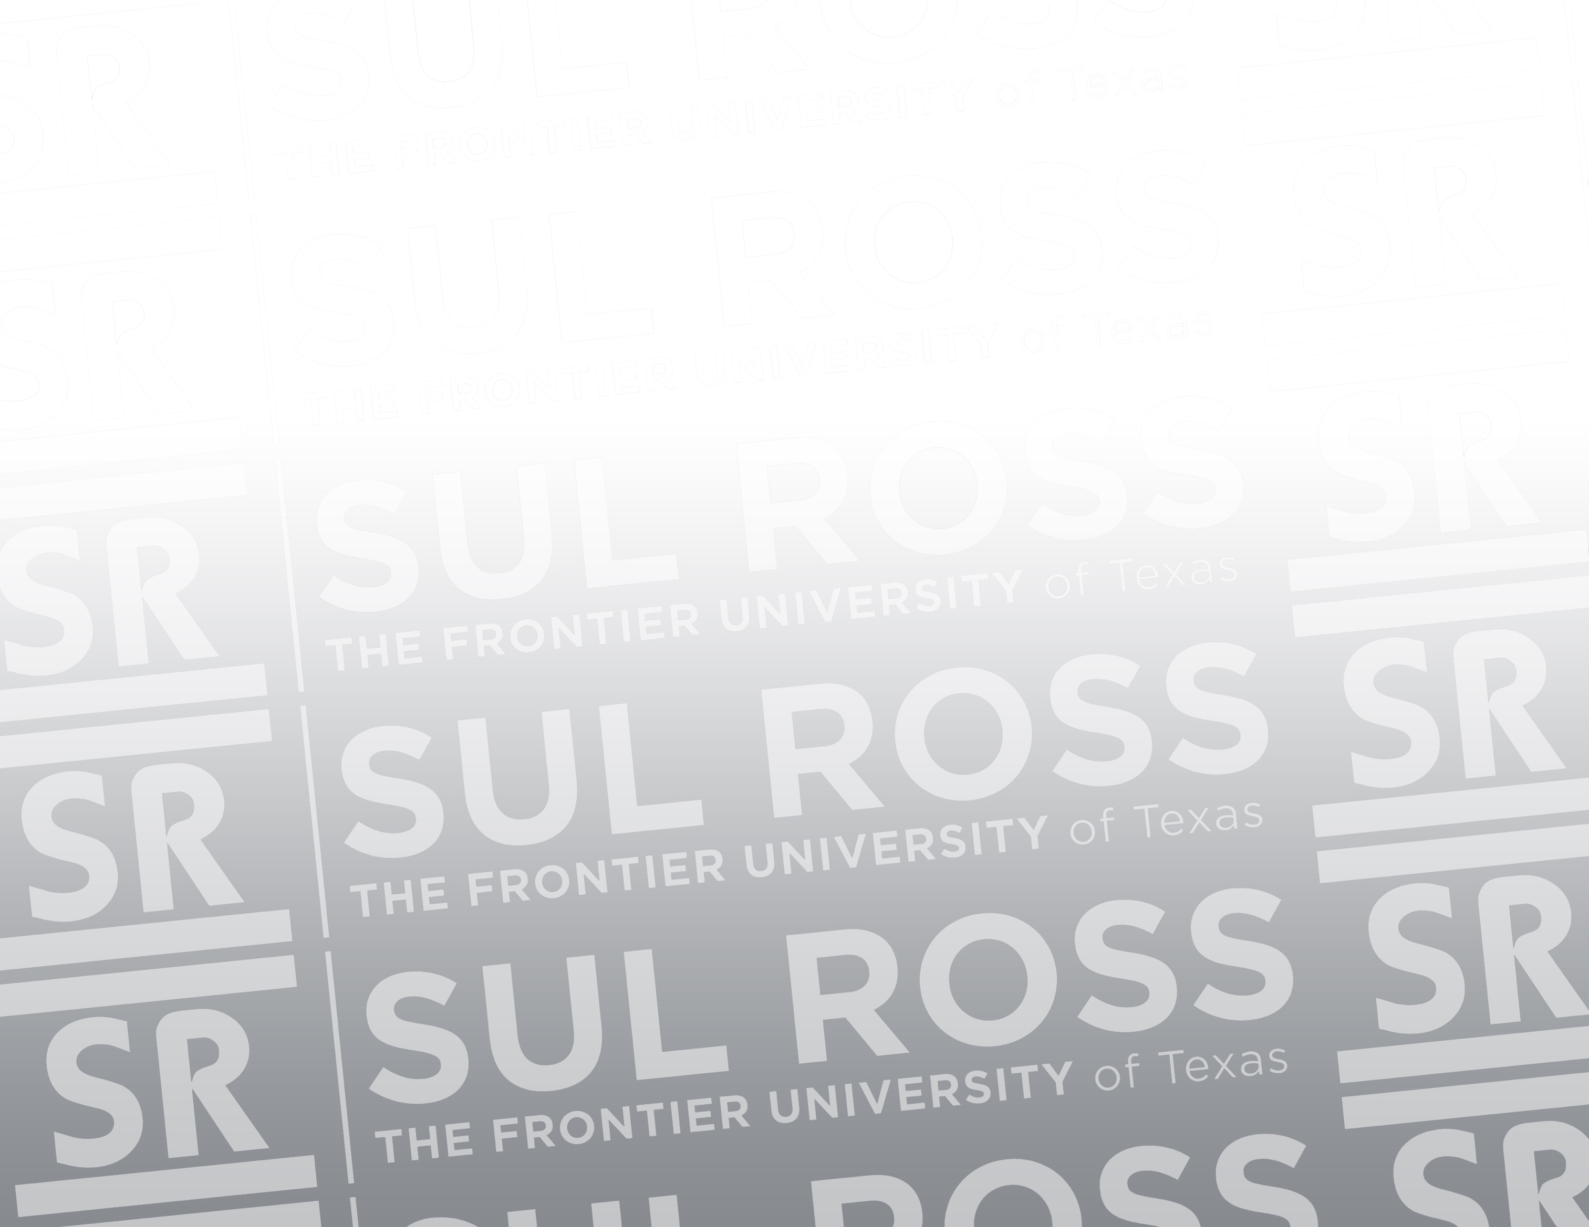

Institutional Effectiveness
Analysis of the SRSU Campus Environment Survey

Prepared by
April Aultman Becker, Assistant VP for Institutional Effectiveness
July 15, 2023

Contents

Executive Summary 3
Section One: 9
Section Two: 15
Section Three 17
Section Four 19
Section Five 24
Appendix 26
A. Recognition 27
B. Faculty/Staff Disaggregated by Alpine and RGC 29

Executive Summary

The Office of Institutional Effectiveness initiated the inaugural Sul Ross State University Campus Environment Survey in September 2020, and has conducted it every spring since then. The latest survey was available for responses from April 13, 2023, until May 5, 2023.

The survey items were initially developed by members of the Guiding Coalition, who began work on this assessment in November 2019. The Guiding Coalition developed the questions in five areas: 1) Campus climate; 2) Commitment to students, faculty, and staff; 3) Work-life balance; 4) Administration; 5) Fair treatment/ Absence of discrimination. Since the inaugural survey, the questions have undergone review and received some updates. However, the survey questions have seen minimal changes. The 2023 survey had 78 questions and one open-response question.

Response Rates – Decreased at both campuses from Spring 2022-Spring 2023:

Spring 2022: 425 responses, 18% of the entire SRSU community. Eighty-four percent (84%) of the participants were from Alpine, and sixteen percent (16%) were from Rio Grande College.

Spring 2023: 228 responses, representing 11% of the entire SRSU community. Eighty-three percent (83%) of the participants were from Alpine, and seventeen percent (17%) were from Rio Grande College.

Significant Gains from 2022 to 2023:

Faculty and Staff’s ratings for “I feel valued at work” increased from 53.1% in 2022 to 56.4% in 2023.

Areas for Concern:

Students’ results showed a significant drop in agreement with the statement, “Generally, I feel welcome on my campus.” In Alpine, in 2022, (78.1%) of students agreed that they felt welcome, while the percentage dropped to 63.8% in 2023. In RGC, positive responses decreased from 79.1% in 2022 to 53.3% in 2023.

Faculty and Staff in Alpine reported dissatisfaction with the maintenance of facilities. In 2022, 35.8% of Alpine faculty and staff reported that facilities were well-maintained, while in 2023, only 22.7% were satisfied. In RGC, satisfaction with facilities improved slightly, with 55.0% in 2022 and 58.8% in 2023.

Faculty, Staff, and Students reported a decrease in their agreement with the statement, “Communication across the University is effective.” Overall, satisfaction with university communication dropped from 42.8% in 2022 to 26.1% in 2023.

Quantitative Summary for All Campuses
Participant Distribution

Survey participation by key stakeholders varied from 2021 through 2023 as indicated below:

Spring 2021 Spring 2022 Spring 2023
Students: 66.4% 49.1% 31.3%
Staff: 19.6% 32.5% 40.9%
Faculty/Adjunct Faculty 12.8% 15.9% 23.9%
Administrators 1.2% 2.6% 3.9%

The key response areas in the section below were established during the Spring 2021 survey analysis. To maintain some consistency within the reporting, these key response areas are shown below with Spring 2022 and 2023 results.

Student Responses to Key Survey Items (Agree to Strongly Agree)

Student responses decreased in all of the following areas except for the increase in the percentage of students concerned about their ability to afford balanced meals.

 | Spring 2021 |  | Spring 2022 |  | Spring 2023
 | Agree to Strongly Agree | Positive/ Responses | Agree to Strongly Agree | Positive/ Responses | Agree to Strongly Agree | Positive/ Responses
I feel welcome on campus. | 79.9% | 211/264 | 78.5% | 142/181 | 61.3% | 38/62
I would recommend this university to others. | 75.8% | 201/265 | 73.5% | 133/181 | 54.1% | 33/61
I will likely attend SRSU next year. * | 81.7% | 170/208 | 79.3% | 115/146 | 78.4 | 40/51
* Note: Students who reported they were graduating were removed from the calculation.
I worry whether I can afford to feed myself. | 41.3% | 109/264 | 34.8% | 63/181 | 45.8% | 27/59

Faculty/Staff Responses to Key Survey Items (Agree to Strongly Agree)

The following Faculty/Staff key survey items consistently increased in satisfaction from Spring 2021 through Spring 2023. As in 2022, the only item with at least 50% agreement over the three years is “The University supports a positive work-life balance.”

 | Spring 2021 |  | Spring 2022 |  | Spring 2023
 | Agree to Strongly Agree | Positive/ Responses | Agree to Strongly Agree | Positive/ Responses | Agree to Strongly Agree | Positive/ Responses
The University actively seeks faculty and employee input in decision-making regarding campus matters. | 29.0% | 38/131 | 36.0% | 64/178 | 32.8% | 45/137
I would recommend this university to others as a place to work. | 42.3% | 55/130 | 47.2% | 84/178 | 43.2% | 60/139
The University supports a positive work-life balance. | 38.9% | 51/131 | 51.7% | 92/178 | 50.0% | 69/138
The University values its employees. | 46.6% | 61/131 | 48.0% | 85/177 | 48.6% | 68/140

Combined Responses from All Faculty, Staff, and Students to Key Survey Items (Agree to Strongly Agree)

Combined response results (faculty, staff, and students) were consistently down from Spring 2021 through Spring 2023. Questions related to the effectiveness of university communication (-17%) and the university community’s attitude towards students (-23%) were both down significantly since 2022.

 | Spring 2021 |  | Spring 2022 |  | Spring 2023
 | Agree to Strongly Agree | Positive/ Responses | Agree to Strongly Agree | Positive/ Responses | Agree to Strongly Agree | Positive/ Responses
My campus is supportive of people of different races, ethnicities, gender and sexual identities, and/or cultural backgrounds. | 73.1% | 272/372 | 79.0% | 263/333 | 70.2% | 134/191
The University is committed to my emotional well-being. | 52.1% | 195/374 | 52.3% | 183/350 | 42.0% | 84/200
The SRSU community cares about each student as a person. | 62.8% | 235/374 | 61.0% | 213/349 | 38.4% | 76/198
Communication among people across the University is effective. | 46.4% | 173/373 | 42.8% | 149/348 | 26.1% | 52/199

Qualitative Summary for All Campuses
One open-response question was included in the survey: “What improvements can you suggest to enhance the overall experience at Sul Ross State University?” It is noteworthy that three of the top five themes that emerged in the responses in Spring 2021 continued to be expressed in Spring 2022, and once again in Spring 2023.
Theme | # Responses in Spring 2021 | # Responses in Spring 2022 | # Responses in Spring 2023
Facilities | 45 | 41 | 80
Quality of Service | 37 | 106 | 71
Staff/Faculty Salaries and Benefits | 23 | 32 | 50

Significant Differences between Alpine Responses and Rio Grande College Responses on Spring 2023 Survey
(Noted for items with + or – 5% points differences)

Participant Distribution

Fewer surveys were completed in Spring 2023 when compared with 2021 or 2022. The largest drop in participation for both campuses was among students. The RGC percentage of surveys completed by students (-20%) and staff (-5%), decreased while faculty surveys increased (+19%). For Alpine, student surveys decreased (-18%) while both staff (+9%) and faculty (+9%) participation increased.

 | Spring 2021 |  | Spring 2022 |  | Spring 2023
 | RGC | Alpine | RGC | Alpine | RGC | Alpine
Student | 68 (82%) | 212 (63%) | 44 (66%) | 163 (47%) | 16 (46%) | 53 (29%)
Staff | 6 (7%) | 75 (22%) | 17 (25%) | 118 (34%) | 7 (20%) | 79 (43%)
Faculty | 8 (10%) | 41 (12%) | 6 (7%) | 52 (15%) | 9 (26%) | 44 (24%)
Administrator | 1 (1%) | 4 (1%) | 0 (0%) | 11 (3%) | 2 (6%) | 7 (4%)
Adjunct | 0 (0%) | 4 (1%) | 0 (0%) | 4 (1%) | 1 (3%) | 1 (1%)

Responses for Key Survey Items- Students
(Very Likely to Likely or Strongly Agree to Agree)

1. Likely to Return to SRSU*

RGC’s expected return rate in Spring 2023 dropped (-34.4%) while Alpine’s expected return rate increased (10.2%).

 | Spring 2021 |  | Spring 2022 |  | Spring 2023
 | RGC | Alpine | RGC | Alpine | RGC | Alpine
Student | 40 (76.9%) | 129 (83.2%) | 30 (88.2%) | 85 (76.6%) | 7 (53.8%) | 33 (86.8%)
* Note: Students who reported they were graduating were removed from the calculation

2. Food Security/Insecurity

Food insecurity among students rose for RGC (7.7%) and Alpine (12.5%) from 2022 to 2023.

 | Spring 2021 |  | Spring 2022 |  | Spring 2023
 | RGC | Alpine | RGC | Alpine | RGC | Alpine
Student | 14 (23.0%) | 94 (46.5%) | 9 (20.9%) | 53 (38.6%) | 4 (28.6%) | 23 (51.1%)

RESPONSES FOR KEY SURVEY ITEMS- Faculty and Staff
(Agree to Strongly Agree)

- Decision-Making and Work-Life Balance

Faculty and staff at both Alpine and RGC reported slightly decreased levels of satisfaction from 2022 to 2023 with the item “SRSU Seeks Faculty/Employee Input in Decision-Making.” RGC ratings decreased from 35% to 31.3%, and Alpine ratings decreased from 36.1% to 33.1%. The item, “Satisfaction with Work-Life Balance”, also received lower ratings in 2023. RGC ratings decreased from 50% to 37.5%, and Alpine ratings decreased from 51.9% to 51.6%.

 | Spring 2021 |  | Spring 2022 |  | Spring 2023
 | RGC | Alpine | RGC | Alpine | RGC | Alpine
SRSU Seeks Faculty/Employee Input in Decision-Making | 4 (28.6%) | 34 (29.6%) | 7 (35%) | 57 (36.1%) | 5 (31.3%) | 40 (33.1%)
Satisfaction with Work-Life Balance | 4 (28.6%) | 44 (39.6%) | 10 (50%) | 82 (51.9%) | 6 (37.5%) | 63 (51.6%)

2. Campus Facilities Well-Maintained

The combined responses for facility maintenance increased slightly from Spring 2022 to Spring 2023 for the RGC campus (+3.8%); however, Alpine saw a 13.1% decrease in satisfaction over the same period.

 | Spring 2021 |  | Spring 2022 |  | Spring 2023
 | RGC | Alpine | RGC | Alpine | RGC | Alpine
Facilities Well-Maintained | 11 (78.6%) | 39 (36.4%) | 11 (55%) | 53 (35.8%) | 10 (58.8%) | 27 (22.7%)

3. Communication across Campuses

Faculty and staff responses from RGC indicated a slight drop (2.2%) in satisfaction with effective communication across campuses, while Alpine ratings dropped by 3.2%. Both campuses rated communication below 30%.

 | Spring 2021 |  | Spring 2022 |  | Spring 2023
 | RGC | Alpine | RGC | Alpine | RGC | Alpine
Communication on Campus is Effective | 5 (35.7%) | 22 (20.7%) | 6 (31.6%) | 36 (23.7%) | 5 (29.4%) | 25 (20.5%)

Analysis of the SRSU Campus Environment Survey
In this report, Section One will highlight key findings in the quantitative results for specific areas; Section Two will highlight key areas for students; Section Three will feature faculty and staff responses; Section Four will address qualitative results; and Section Five will present conclusions and recommendations.

Section One: Quantitative Results
- Multiple Choice Responses: Students

Students from all campuses will be reported as combined since significant differences between Alpine and RGC have already been identified in the Executive Summary.

Student Breakdown

Students by Classification
 | Spring 2021 | Spring 2022 | Spring 2023
Undergraduate Freshman | 11.00% | 13.80% | 11.10%
Undergraduate Sophomore | 11.70% | 15.70% | 19.40%
Undergraduate Junior | 23.20% | 24.30% | 29.20%
Undergraduate Senior | 31.30% | 25.70% | 27.80%
Graduate Student | 20.60% | 16.70% | 8.30%
Other | 2.20% | 3.80% | 4.20%

Students by Gender
 | Spring 2021 | Spring 2022 | Spring 2023
Female | 72.40% | 59.90% | 60.9%
Male | 26.20% | 38.20% | 21.7%
Other | 1.40% | 1.90% | 17.4%

Students by Race/Ethnicity
 | Spring 2021 | Spring 2022 | Spring 2023
African American or Black | 4.80% | 10.40% | 4.3%
Hispanic or Latinx | 59.00% | 53.20% | 46.4%
White | 33.60% | 32.30% | 37.7%
Other | 2.60% | 3.80% | 11.6%

First Generation Students
 | Spring 2021 | Spring 2022 | Spring 2023
First Generation | 52.50% | 51.30% | 52.3%

The survey measured satisfaction in five areas: Climate; University support; Work-life balance; Administration; and Fair treatment/Absence of discrimination. Selected questions from the survey represent students’ thoughts on the five areas.

Area 1: Campus Climate
In Spring 2021, 162/250 (64.8%) of students reported a satisfaction level (agree or strongly agree) with campus climate by responding to the item: The campus offers a healthy living and learning environment. Satisfaction increased slightly in Spring 2022 at 67.8% (119/177), but decreased for 2023 with a reported satisfaction level for campus climate of 48.3% (29/60).

Area 2: University Commitment to Students
In Spring 2021, 211/264 (79.9%) of students reported a perceived sense of university commitment (agree or strongly agree) in this representative item: Generally, I feel welcome on my campus. This level of agreement continued in Spring 2022 at 78.3% (141/180), but decreased significantly in 2023 with a satisfaction rate of 61.3% (38/62).

Area 3: Work-Life Balance
In Spring 2021, 198/265 (74.7%) of students reported an adequate work-life balance (agree or strongly agree) in their responses to the item: Faculty respect my need to balance course work with other responsibilities in my life. In Spring 2022, 67.4% (122/181) of students reported an adequate work-life balance. Students’ agreement with this question further decreased to 57.4% (35/61).

Area 4: Administration
In Spring 2021, 143/251 (57.0%) of students reported on input with administration (agree or strongly agree) to the following item: The University actively seeks students’ input in decision-making regarding campus matters. In Spring 2022, 59.3% (107/177) of students reported on input with administration, while in Spring 2023, that percentage decreased to 36.7% (22/60).

Area 5: Fair Treatment/Absence of Discrimination
In Spring 2021, 187/251 (74.5%) of students reported there is fair treatment/ absence of discrimination (agree or strongly agree) as illustrated by responses to the item: My primary university campus is supportive of people of different races, ethnicities, gender and sexual identities and/or cultural backgrounds. In Spring 2022, 82.5% (137/166) of students reported there is fair treatment/ absence of discrimination. In Spring 2023, the percentage of students reporting that there is fair treatment/ absence of discrimination dropped to 58.9% (33/56).

- Multiple Choice Responses- Faculty/Staff

Faculty and staff responses from all campuses are combined in this section. Participation rates in Spring 2023 were lower than participation rates in Spring 2022, as indicated in the table below.

Group | Spring 2021 | Spring 2022 | Spring 2023
Faculty | 54 | 62 | 55
Staff | 83 | 135 | 86

Area 1: Campus Climate
In Spring 2021, 55/130 (42.3%) of faculty and staff selected agree or strongly agree in response to the item: I would recommend this university to others as a place to work. In Spring 2022, 84/178 (47.2%) of faculty and staff stated they would recommend the university to others as a place to work. In Spring 2023, 60/139 (43.2%) of faculty and staff agreed, down from 2022, but slightly higher than 2021.

Area 2: University Commitment to Faculty/Staff
In Spring 2021, 75/131 (57.2%) of faculty and staff selected agree or strongly agree in response to the item: I feel valued at work. In Spring 2022, 94/177 (53.1%) of faculty and staff stated that they felt valued at work. For Spring 2023, positive responses were up slightly, with 79/140 (56.4%) of faculty and staff stating that they felt valued at work.

Area 3: Work-Life Balance
In Spring 2021, 51/131 (38.9%) of faculty and staff rated work-life balance as agree or strongly agree for the item: The university supports a positive work-life balance. In Spring 2022, 92/178 (51.7%) of faculty and staff rated a positive work-life balance. Spring 2023 showed a very slight decrease, with 69/138 (50%) agreeing that the university supports a positive work-life balance.

Area 4: Administration
In Spring 2021, 38/131 (29.0%) of faculty and staff rated their opportunities to provide input to administration as agree or strongly agree for the item: The University actively seeks faculty and employee input in decision-making regarding campus matters. In Spring 2022, 64/178 (36.0%) of faculty and staff rated their opportunities to provide input to administration. In Spring 2023, 45/137 (32.8%) of faculty and staff rated their opportunities to provide input to administration.

Area 5: Fair Treatment/Absence of Discrimination
In Spring 2021, 85/121 (70.2%) of faculty and staff rated fair treatment and absence of discrimination as agree or strongly agree for the item: My primary university campus is supportive of people of different races, ethnicities, gender and sexual identities, and/or cultural backgrounds. In Spring 2022, 126/167 (75.5%) rated fair treatment and absence of discrimination as agree or strongly agree. For Spring 2023, the number of faculty and staff who rated fair treatment and absence of discrimination as agree or strongly agree stayed fairly consistent at 101/135 (74.8%).

- Comparisons of Student, Faculty, and Staff Responses to Selected Multiple Choice Questions

Area 1: Climate

Item: Campus offers a healthy living and learning environment

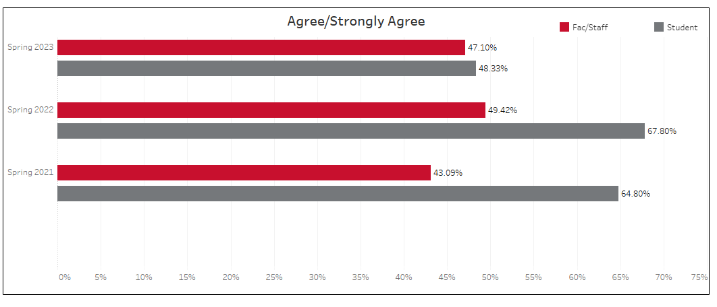

Area 2: Commitment to Students, Faculty, and Staff

Item: The university cares about each student as a person
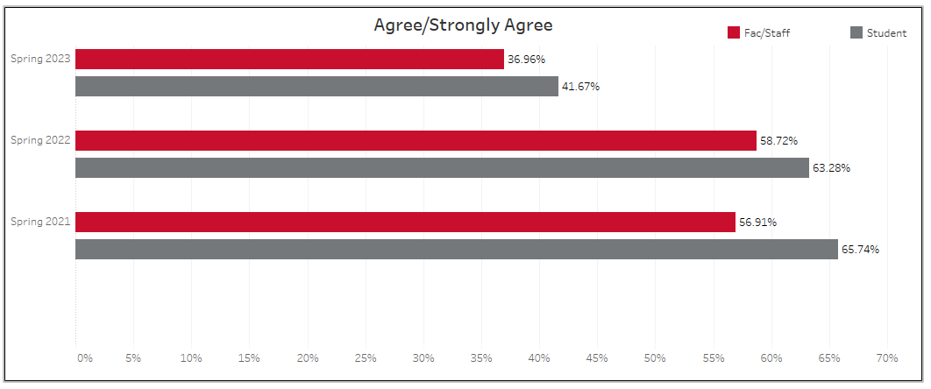

Area 3: Work-Life Balance
Item: The University supports a positive work-life balance (NOTE: The student question is: Faculty respect my need to balance course work with other responsibilities in my life.)

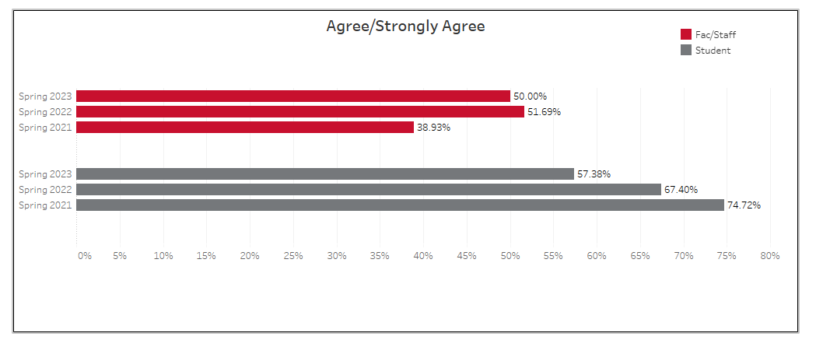

Area 4: Administration

Item: The University actively seeks input in decision-making regarding campus matters

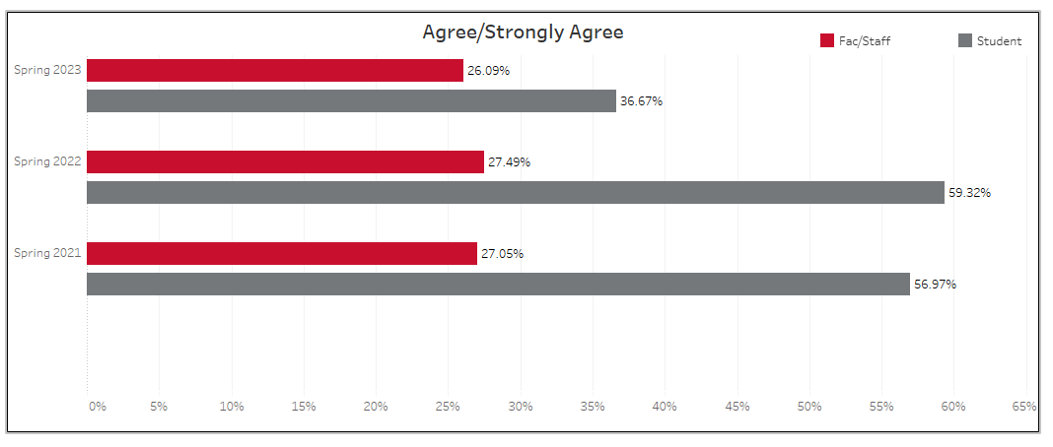

Area 5: Fair Treatment/Absence of Discrimination

Item: My campus is supportive of people of different races, ethnicities, gender and sexual identities, and/or cultural background

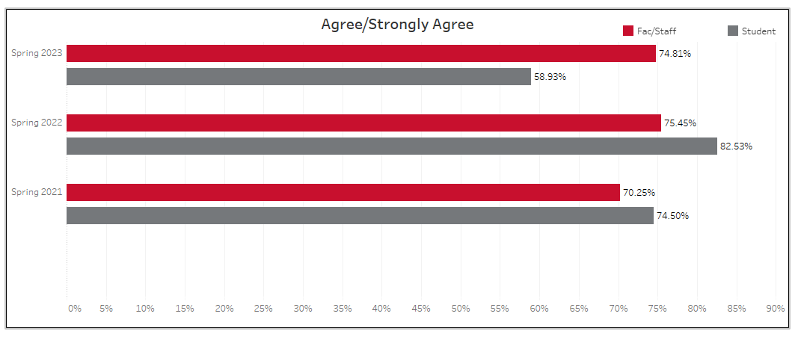

Section Two: Student Responses to Key Areas
Spring 2021 - Spring 2023

The charts below provide visualizations of student responses to various questions. The “Positive” (red) bar indicates the percentage of students who Agreed/Strongly Agreed. The “Neutral” (gray) bar indicates the percentage of students who chose Neither Agree or Disagree. The “Negative” (black) bar indicates the percentage of students who Disagreed/Strongly Disagreed. The lowest scores occurred in Spring 2023 for “Communication Across SRSU is Effective” (37%). At a personal level, students remain concerned about affording balanced meals (41% in 2021, 35% in 2022, and 46% in 2023).

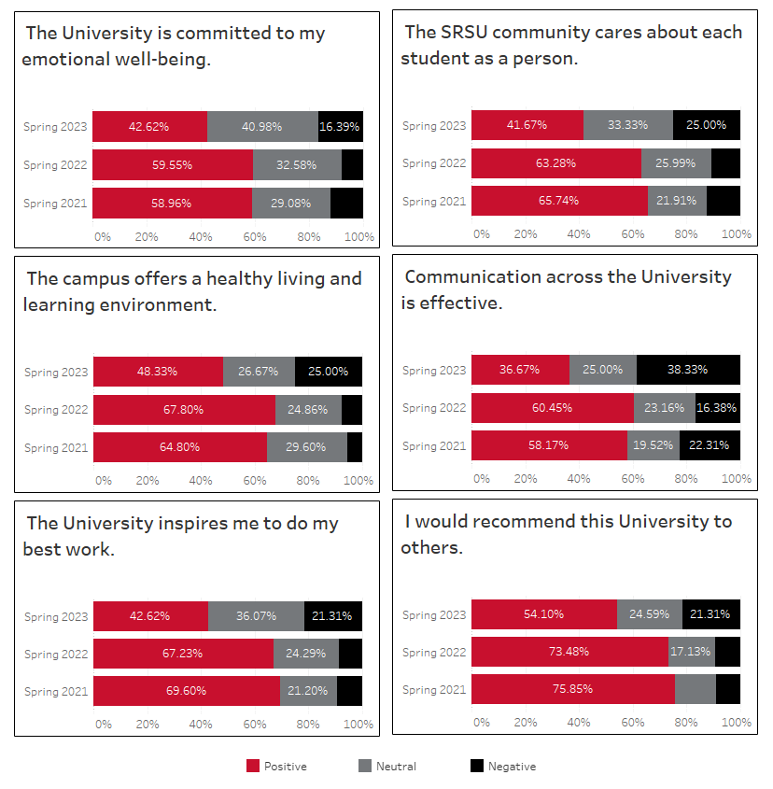

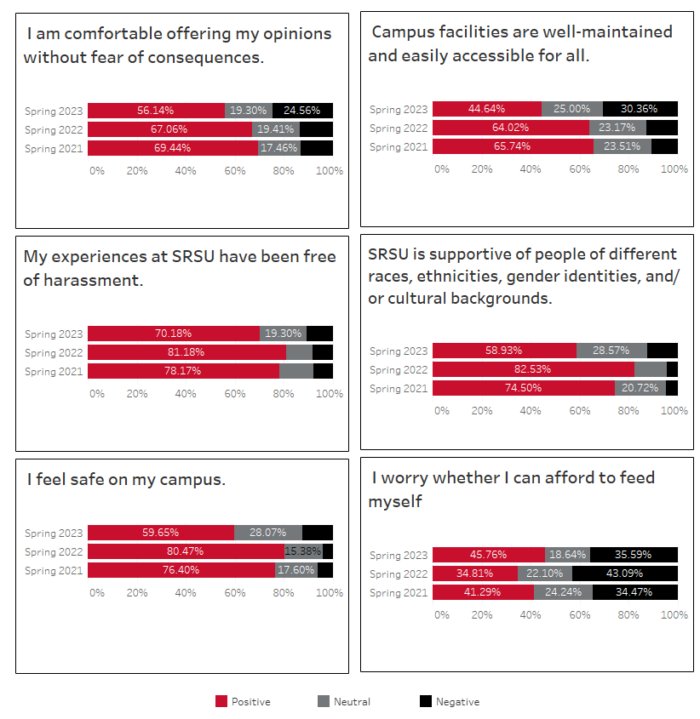

Section Three: Faculty/Staff Responses to Key Areas
Spring 2021 - Spring 2023
(Breakdown by Alpine and RGC available in Appendix B)
For the combined results of faculty and staff, the lowest rated areas were “Communication Across SRSU is Effective” (22% in Spring 2021, 25% in Spring 2022, and 22% in Spring 2023) and “Campus facilities are well-maintained and easily accessible for all” (41% in Spring 2021, 38% in Spring 2022, and 27% in Spring 2023). There was a significant increase of 10% in “I am comfortable with offering my opinions without fear of consequences” (39% in Spring 2021, 36% in Spring 2022, and 46% in Spring 2023).
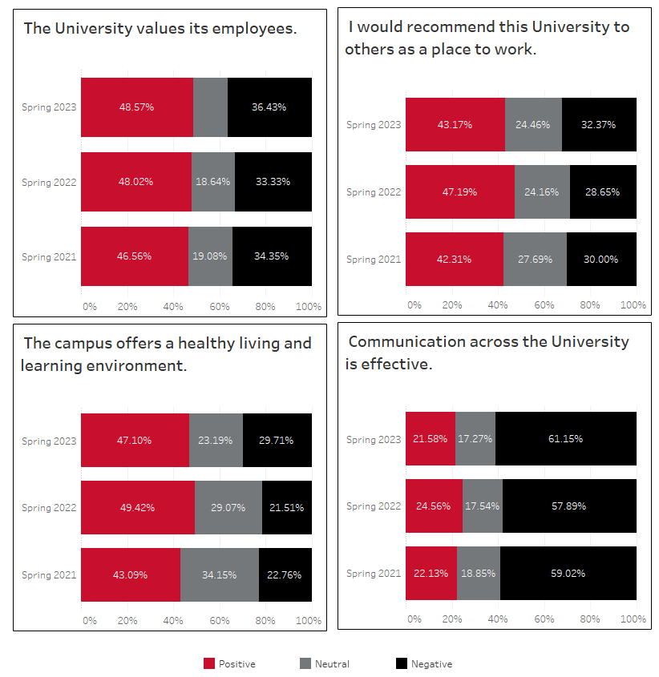
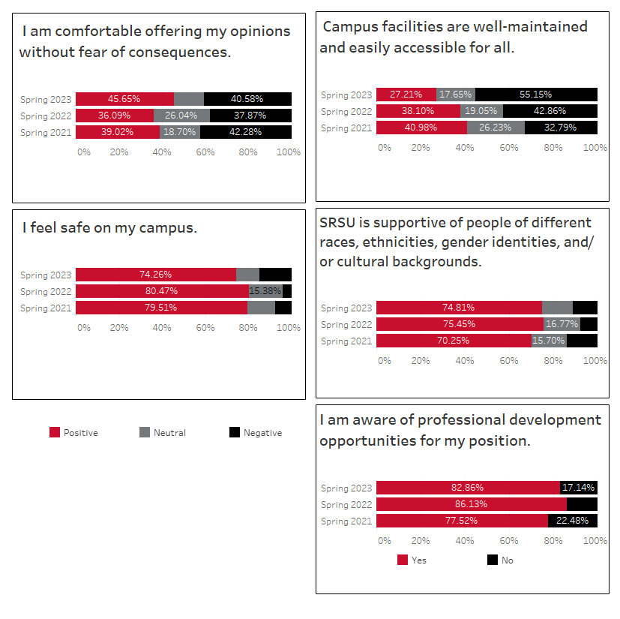

Section Four: Qualitative Responses
Spring 2021
In 2021, there were 154 individual responses. Those responses were divided into 207 discrete items and classified by two independent researchers into 11 categories.

Theme | Brief Description | # Items | Faculty | Staff | Students
Facilities | Concerns regarding parking lots, buildings maintenance, and elevators and more staffing for maintenance---Alpine Campus | 45 | 10 | 5 | 30
Quality of Services | Library hours, financial aid services, advising, concerns regarding faculty professionalism, signage, need for good customer service practices | 37 | 2 | 3 | 32
Staff/Faculty Wages and Positions | Concerns for more custodial positions and higher salaries. Concerns for more faculty hiring. Request for more professional development. Request for competitive compensation. | 23 | 11 | 11 | 1
Communication | Concerns with exchanges between students and offices, between departments, and across campuses. Communication should be timely | 22 | 7 | 9 | 6
Positive about SRSU | Positive statements such as: “Sul Ross is a great place, and I am really enjoying being a part of the community.” | 20 | 4 | 0 | 16
Lack of Support | Designated counselors for registering, replying to emails, mentorship for junior faculty, on-boarding, support of students, etc. | 20 | 10 | 4 | 6
Diversity | Concerns over divisions between younger and older students, ability to disagree with civility, the Sul Ross statue, and recognizing multiple perspectives | 19 | 6 | 5 | 8
Administration | Concerns over inclusion of faculty and staff in decision making, need for transparency, valuing employees, budgets, and concerns regarding work study and graduate students | 10 | 1 | 5 | 4
Expand Online Programs | Increase online offerings – courses and programs | 6 | 1 | 0 | 5
Budget | Resources scarce, sports vs. academics | 3 | 1 | 1 | 1
Retention | Retention of sports players, creating more events for retention | 2 | 0 | 1 | 1

Spring 2022
In 2022, there were 152 individual responses. Those responses were divided into 319 discrete items and classified into eight categories by two independent researchers. The table below also reports the distribution of comments among stakeholders.

Concerns reported in 2021 about Diversity, Online Programs, and Retention were not reported in 2022. This may be due to the significant activities undertaken in those three areas by the university during the 2021-2022 academic year.

Lack of Support from 2021 was reflected in Quality of Services in 2022, and Budget was reflected in Issue with Administration in 2022. Two new themes that emerged in 2022 included Concerns about Aramark and Low Morale. There were 21 references to Aramark, and 18 of them were from students. There were 18 references to Low Morale.

Theme | Brief Description | # Items | Faculty | Staff | Students
Facilities | Concerns regarding parking lots, buildings maintenance, and elevators and more staffing for maintenance---Alpine Campus | 41 | 11 | 13 | 17
Quality of Services | Library hours, financial aid services, advising, concerns regarding faculty professionalism, signage, need for good customer service practices | 106 | 11 | 29 | 66
Competitive salaries for faculty and staff | Concerns for more custodial positions and higher salaries. Concerns for more faculty hiring. Request for more professional development. Request for competitive compensation. | 32 | 14 | 17 | 1
Communication | Concerns with exchanges between students and offices, between departments, and across campuses. Communication should be timely | 38 | 13 | 20 | 5
Positive about SRSU | Positive statements such as: “Sul Ross is a great place, and I am really enjoying being a part of the community.” | 16 | 5 | 2 | 9
Issues with Administration | Concerns over inclusion of faculty and staff in decision making, need for transparency, valuing employees, budgets, and concerns regarding work study and graduate students | 47 | 18 | 27 | 2
Concerns about Aramark | Concerns with food options and quality | 21 | 2 | 1 | 18
Low morale expressed | Concerns about faculty and staff morale | 18 | 8 | 7 | 3

Spring 2023
In 2023, there were 106 individual responses. Those responses were divided into 433 discrete items and classified into eight categories. The table below also reports the distribution of comments among stakeholders. Concerns about physical and building safety, as well as technology, were separated out into their own themes for the 2023 report. The “Competitive salaries for faculty and staff” theme was changed to “Improved salaries and benefits for faculty and staff” to describe better the non-salary benefits that employees mentioned in the comments.

Theme | Brief Description | # Items | Faculty | Staff | Students
Facilities | Concerns regarding parking lots, buildings maintenance, and elevators and more staffing for maintenance---Alpine Campus | 80 | 15 | 43 | 22
Safety and Security | Concerns about physical safety on campus as well as facility ADA compliance. | 20 | 0 | 14 | 6
Technology | Concerns about availability and usage of classroom and non-classroom technology, Wi-Fi speed, and similar issues. | 10 | 7 | 0 | 3
Quality of Services | Library hours, financial aid services, advising, concerns regarding faculty professionalism, signage, need for good customer service practices | 71 | 8 | 26 | 37
Improved salaries and benefits for faculty and staff | Concerns for more custodial positions and higher salaries. Concerns for more faculty hiring. Request for more professional development. Request for competitive compensation. | 50 | 15 | 34 | 1
Communication | Concerns with exchanges between students and offices, between departments, and across campuses. Communication should be timely | 36 | 8 | 23 | 5
Positive about SRSU | Positive statements such as: “Sul Ross is a great place, and I am really enjoying being a part of the community.” | 15 | 2 | 11 | 2
Issues with Administration | Concerns over inclusion of faculty and staff in decision making, need for transparency, valuing employees, budgets, and concerns regarding work-study and graduate students | 83 | 39 | 40 | 4
Concerns about Aramark | Concerns with food options and quality | 39 | 2 | 5 | 32
Low morale expressed | Concerns about faculty and staff morale | 29 | 13 | 10 | 6

Qualitative Summary for All Campuses

In Spring 2021, there were 154 individual responses representing 36% of the participants. Eleven themes were identified. The top five themes were:

- Issues with facilities 45 comments)
- Quality of services (37 comments)
- Issues with communication (22 comments)
- Issues with diversity (19 comments)
- Administrative issues (10 comments)

In Spring 2022, there were 152 individual responses representing 36% of the participants. Eight themes were identified. The top five themes were:

- Quality of Services (106 comments)
- Issues with administration (47 comments)
- Facilities (41 comments)
- Issues with communication (38 comments)
- Competitive salaries for faculty and staff (32 comments)

In Spring 2023, there were 106 individual responses representing 46% of the participants. Ten themes were identified. The top five themes were:

- Issues with administration (83 comments)
- Facilities (80 comments)
- Quality of services (71 comments)
- Improved salaries and benefits for faculty and staff (50 comments)
- Concerns about Aramark (39 comments)

Section Five: Conclusions and Recommendations
Conclusions

The Spring 2023 response rate dropped to 11% from 18% in Spring 2022, which may indicate some disengagement or possibly survey fatigue among the university community.

Challenges
- Communication continues to be a concern both in the multiple-choice questions and the open-ended responses.

- Students’ responses to the question: “Faculty respect my need to balance course work with other responsibilities in my life.” decreased once again, this time by ten percentage points after falling by 7.3 points from 2021 to 2022.

- Facilities maintenance continues to present an issue among Alpine faculty and staff, where satisfaction with maintenance and accessibility declined from 35.8% in 2022 to 22.7% in 2023.

Successes
- While faculty and staff at Alpine were unsatisfied with facilities maintenance, RGC faculty and staff reported a slight increase in satisfaction, from 55% in 2022 to 58.8% in 2023, though still down about 20 percentage points from 2021.

- Faculty and staff agreement with the statement, “I am comfortable offering my opinions without fear of consequences,” has risen 11 percentage points from Spring 2022 to Spring 2023.

- Sul Ross has made significant gains in professional development after the launching of the Professional Development Initiative in January 2021. In 2021, 78% of faculty and staff reported, “I am aware of professional development opportunities for my position,” while that percentage has eclipsed 80% in 2022 and 2023.

- Sul Ross has increased awareness of diversity and inclusion on campus. Faculty and staff responses to “My primary university campus is supportive of people of different races, ethnicities, gender and sexual identities and/or cultural backgrounds” has been rated highly in 2021 at 70% and in 2022 and 2023 at 75%.

- Among the students who responded to the survey, 81.8% in Spring 2021, 79.3% in Spring 2022, and 78.4% in Spring 2023 reported that “I will likely attend SRSU next year. This consistency is a very promising indicator for retention.

Recommendations

- The Guiding Coalition will continue to provide leadership for the annual Campus Environment Survey.

- The data will be shared with committees with related missions, and they will be encouraged to set goals for increasing positive responses.

- The data will be used for targets in the 2022-2027 Strategic Plan for specific goals and outcomes.

- Increased participation will continue to be a goal.

Appendix

Recognition
The university is grateful to the members of the Guiding Coalition for their research and development of this survey and their commitment to all faculty, staff, and students to use the data to continually enhance the campus culture for all.
Name | Position | Campus
Alyssa Salles-2021  Anique Lopez- 2022 | SGA President | Alpine
Rosemary Briseno | English Professor | Alpine
Betsy Helesic | Director of the Library | Alpine
Karlin DeVoll | Director of HR | Alpine
Maria Gear | Education Professor | Uvalde
Chris Herrera | Kinesiology & Human Performance  Department Chair | Alpine
Dominick Percoco | OIT | Alpine
Betse Esparza | Public Relations Officer | Alpine
Laura Nelson | Enrollment Marketing and Public Relations | Uvalde
Savannah Williamson | History Professor | Alpine
Suzanne Harris | Dean of Students | Alpine
Kathleen Rivers | Director of McNair Grant | Alpine
April Aultman Becker | Assistant VP for Institutional Effectiveness | Alpine

The university is grateful to members of the Institutional Research team for their contributions to the survey process.
Name | Position | Campus
Greg Marsh | Director of Institutional Research | Alpine
Aaron Majek | Research Associate | Alpine

Faculty/Staff Disaggregated by Alpine and RGC

