IRBNet
Users Manual

IRBNet User Manual

The Institutional Research Board is pleased to provide SRSU researchers with this manual to assist them in using our online protocol submission system, IRBNet. Within this document, you will find step by step instructions and assistance with first-time registration, submission, modifications, and renewal. If you encounter any problems, or have questions regarding the protocol submission process, please contact Deborah Derden, IRB chair, at deborah.derden@sulross.edu or 432-837-8585.

*The SRSU IRB would like to acknowledge the University of Southern Indiana for the use of the information in this document.
Table of Contents

Registering with IRBNet…………………………………………….………………….. 1
Project Creation ……………………………………………………………….………….. 5
Making Requested Revisions ……………………………………………………….15
Modifying an Approved Study …………………………………………………..…16
Renewing an Approved Study or
Submitting a Progress Report ……………………………………………...20
Closing an Approved Study/Final Review ……………………………………...25

*Note: in order to “jump” to an item listed above, place the cursor on the item and push <Enter>. Afterwards, to return to the Table of Contents, place the cursor on the “Return to Table of Contents” entry and push <Enter>.

Registering with IRBNet
(Back to Table of Contents)

- Navigate to http://www.irbnet.org

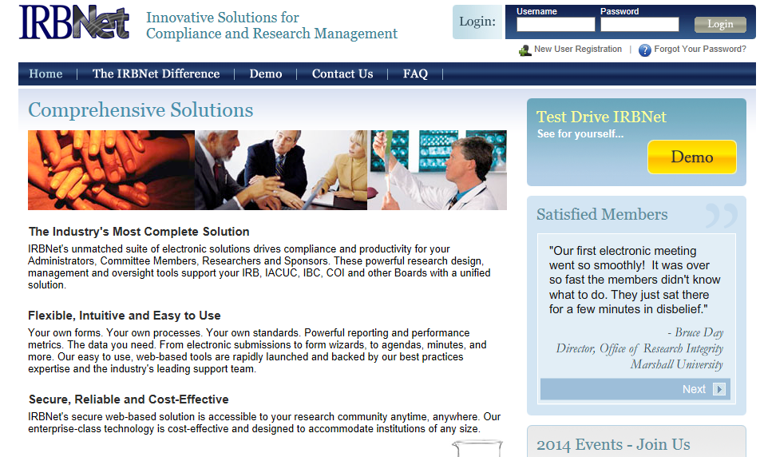

- Look for the login box, located in the upper right portion of the website.

- Click on New User Registration.

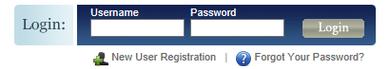

- Fill in the information necessary to create your account.
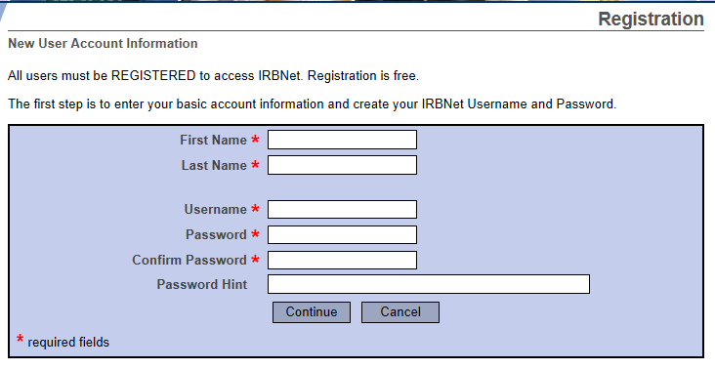
Always use your proper name, with standard capitalization, as this information is used throughout the system.
Passwords must contain eight characters
- Click continue and accept the Terms of Use

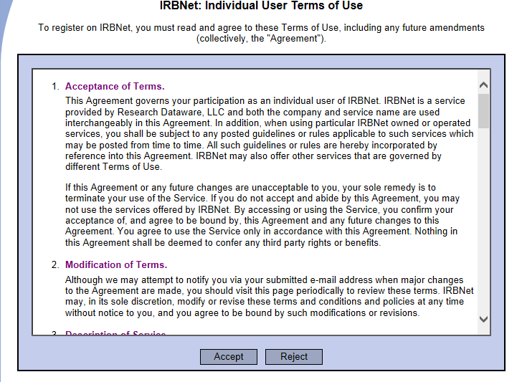
- Select Sul Ross State University. To do this, type Sul Ross State University in the search for an organization space.

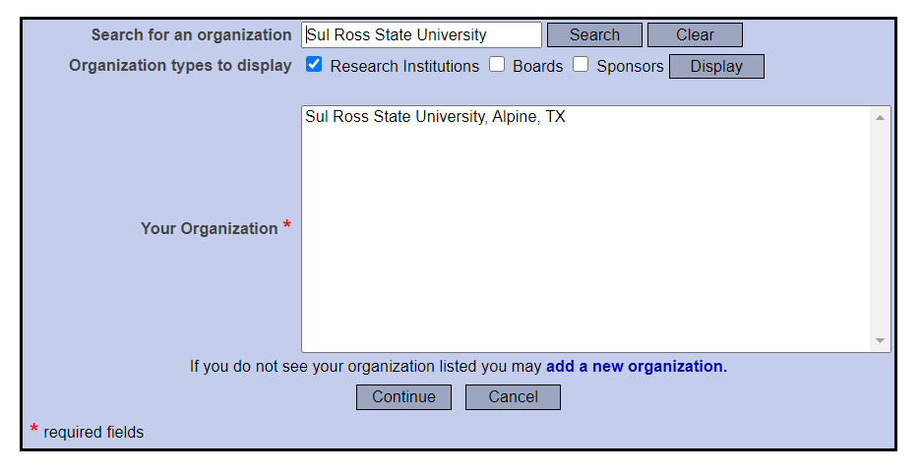
- Click continue and enter your contact information. The e-mail address entered will be the one used to contact you regarding IRB decisions related to your future protocol(s) so make sure it is one you can check OFTEN.

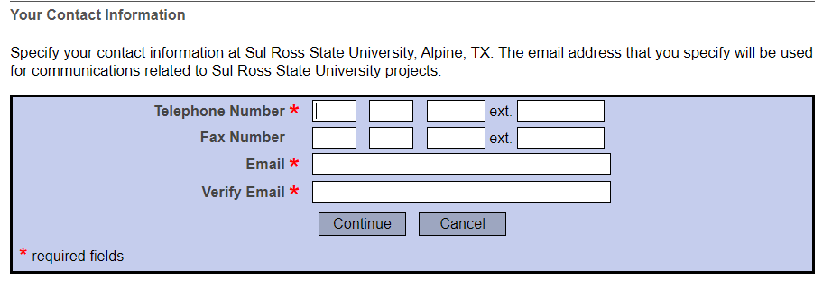

- Confirm that all information that you have entered is correct, and click “Register” to complete the registration process. After you have registered, you may update your account information, and add or update affiliations at any time by logging into IRBNet and accessing your User Profile. Make sure one of your affiliations is “Researcher at Sul Ross State University, Alpine, TX.

- After completing your registration, you will receive an e-mail from IRBNet. Use the provided link within this e-mail to finalize your registration.

Project Creation
(Back to Table of Contents)
- Navigate to www.irbnet.org and login using the username and password you created from the previous section. If you have not created an account, please follow the necessary steps in the Registration section of this manual.

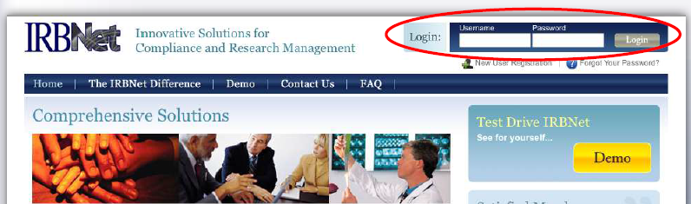

- On the left side of the page, select Create New Project, under “My Projects.”

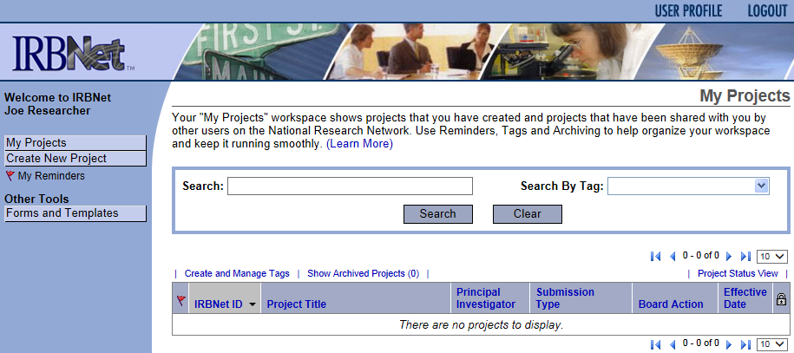

- The following screen will appear:

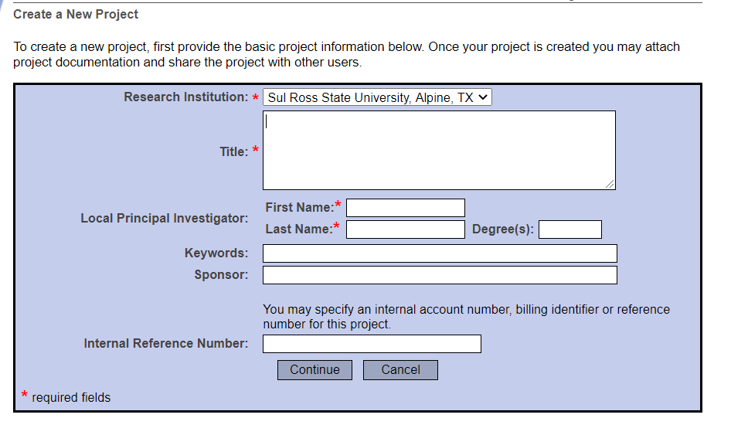

- Enter the title of the project and your name. If the study is sponsored, please enter the funding agency’s name in the sponsor box. The keywords box may be useful for you if you have several studies and need to find this study at a later time based upon a specific keyword.

- Click Continue and you will be taken to the Designer page and this screen.

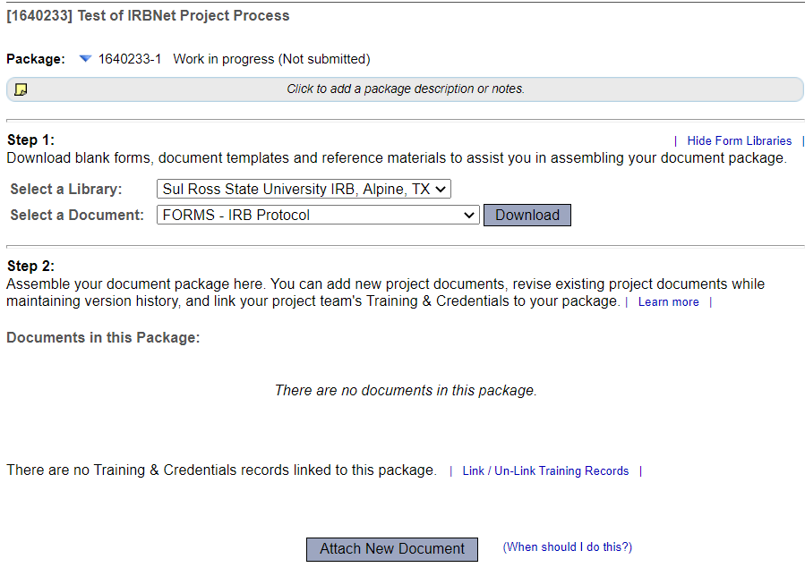

- All forms are located in the Library on IRBNet. To download all necessary forms, click on the “Forms and Templates” tab.
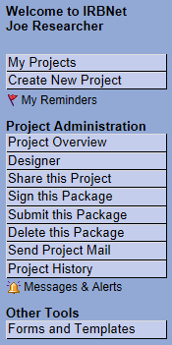

- You will be taken to this screen:
All forms are located in the Library manager on IRBNet.

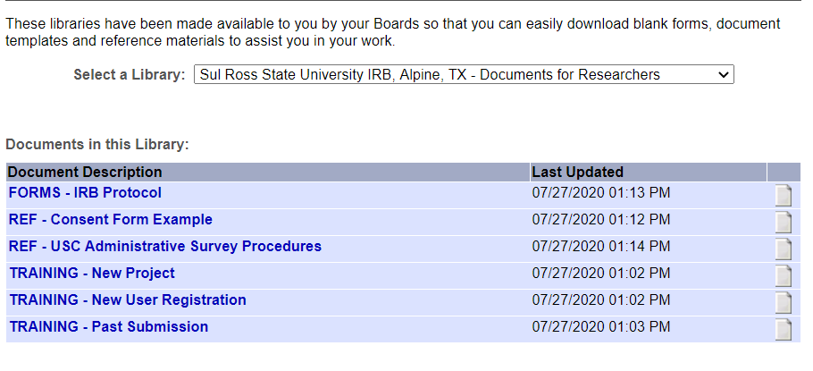

- Download any files by clicking the paper icon next to the title, complete all necessary fields, and save to your computer to upload. Please note: documents will be added and deleted periodically from this Library by the SRSU IRBNet administrator.

- Make sure you have completed all sections of the IRB Protocol and created all separate documents for possible recruitment materials, surveys, and informed consent forms.

- Once all necessary forms have been completed, click My Projects and select your current project.
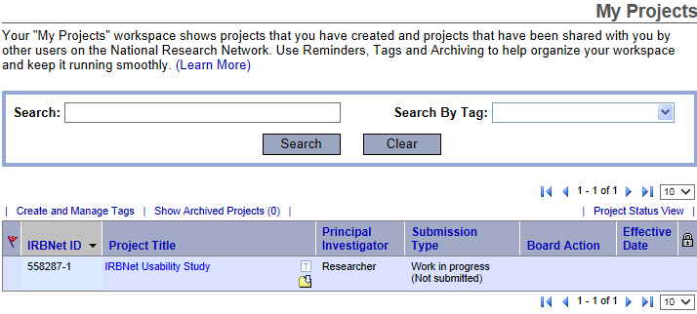

- Navigate to the Designer page to upload application and all supporting documents.

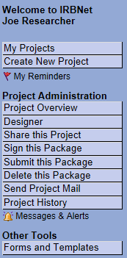

- Once you click, Attach New Document, this screen will appear.
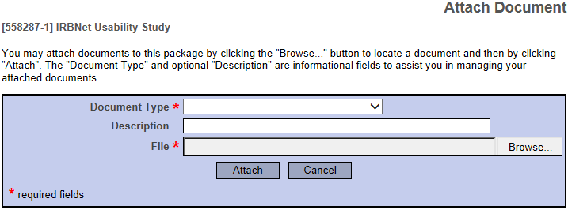

- In the Document Type drop-down box, select Application Form.

- Browse for the file on your computer and click Attach.

- Attach all supporting documents such as surveys, interview questions, CITI Training Completion Reports, site verification letters, etc. as separate documents and label them as such.

- Once all files have been uploaded, you may need to share your study with others. A PI might also share with other advisors or colleagues. To share your project with another person, they must be registered with IRBNet.

- Select the Share this Project tab located on the left side of the page.

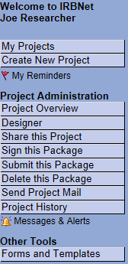

- The following screen will appear, select the first option Share.
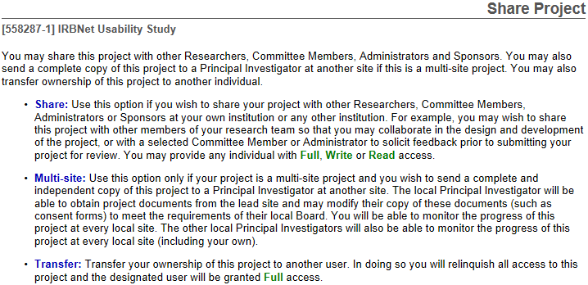

- The following screen will appear, and you can search for the organization with which the person you would like to share the project with is affiliated (Sul Ross State University).

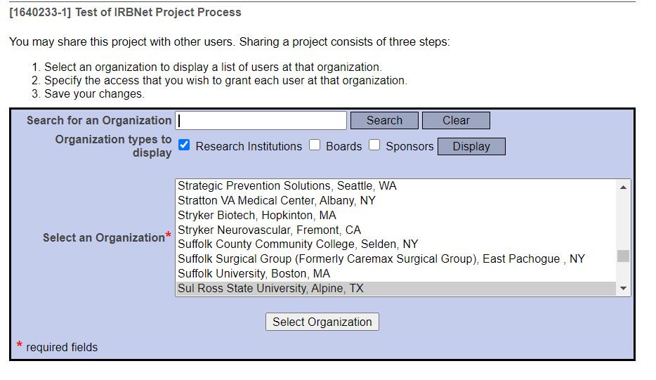

- Once the organization is selected, you will need to search for the specific user using the page below. (User must have their own IRBNet account in order to share with them). Please pay attention to the different sharing levels. You may want an advisor or colleague to have a particular level of access.

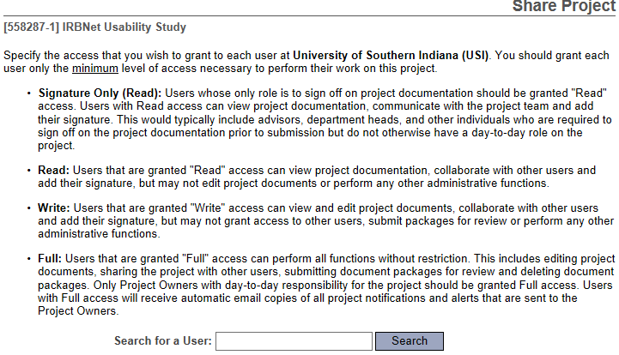

- Once the user is found, you may grant appropriate level of access. Within the comments box, you can enter any additional comments that will be included in the e-mail to the specified IRBNet user which notifies them of their new access to your protocol. Then
click Save.

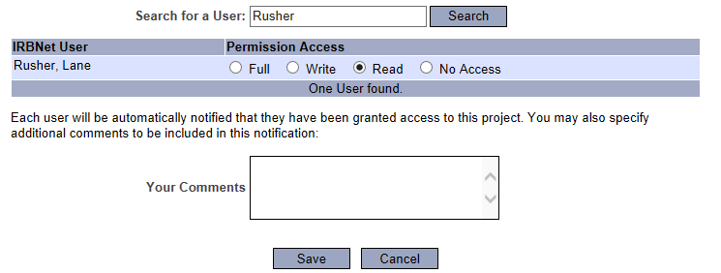

- Click the Sign this Package tab on the left side of the page. Remember, student researchers must have their faculty PI sign the package before they can submit the package for review.

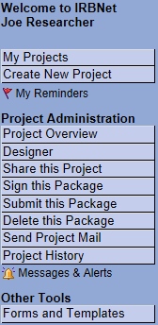

- Select your role in the project. If you are the principal investigator, select this option from the drop down box.

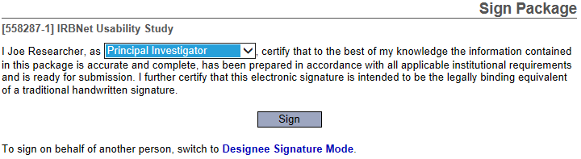

- Once you click Sign, you will receive a notification from IRBNet that you have signed the package. Anyone else that you selected to share the project with will receive an e-mail notifying them of your signature too. Similarly, when your advisor signs the package, you will receive an email notification.

- A package cannot be submitted until everyone has signed the package. If you have a faculty sponsor, the sponsor must sign the package before you submit the package to the IRB for review.
- Unless all signatures are handled at once, you will likely need to access IRBNet at another time once you receive notification that everyone has signed the package. Sign back into your IRBNet account.

- You can select your project from the list after signing in.

- Under Project Administration select Submit this Package.

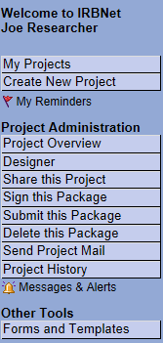

- The Submit Package page will appear. Make sure to select Sul Ross State University IRB, Alpine, TX and click Continue.

- Select New Project, from the dropdown box. Feel free to add any comments and click Submit.

- This will lock your project and the Office of Sponsored Projects and Research Administration will be notified of your submission so the review process can begin. You will receive a time stamp for the submission.

- If you have forgotten to add a necessary document or need to make a quick change to a recently submitted project package, please contact Deborah Derden at deborah.derden@sulross.edu or (432) 837-8585.

Making Requested Revisions
(Back to Table of Contents)
Minor modifications may be necessary after the Institutional Review Board has reviewed your initial protocol submission. This section of the user manual will guide principal investigators in the steps necessary to submit minor modifications. You will receive an e-mail indicating that your project has been unlocked if modifications are required.
- Login to www.irbnet.org with your username and password then click on the My Projects button on the left side of the screen. Select the project you wish to modify.

- If revisions are needed you will see the “Unlocked-Revisions Pending” in red. Click on “Review Details” in blue to see what revisions are requested.

- To view requested changes, click on the most recent letter from the SRSU Institutional Review Board.

- This will bring up a .pdf file of the requested modifications which you can save for your files. Go back to the “Unlocked-Revisions Pending” page to make all necessary changes. When you make changes to a document that is already uploaded, make modifications directly to that document and highlight all changes.

- Once the changes are made, click on Mark Revisions Complete to resubmit the revised study. Keep in mind that your project will be locked and you will be unable to make any further changes after Mark Revisions Complete is clicked.

- If all items from the initial review are correct, your application will then be sent to a reviewer. Keep in mind that reviewers have up to seven business days to complete their review and might comment with additional revisions. In that case, return to step 1 to modify your application again. Allow yourself at least 2 weeks to get approval prior to project start date.

- Upon completion of review you will either get a ‘Modifications Required’ letter or an ‘Approval’ letter. You will receive a notification email and can view the letter upon clicking Review Details on the Designer page.

- This will take you to the page where you can view letters from the Institutional Review Board. If you see a Modifications Required letter, click the paper icon next to it and go back to step 4 in this section of the guidelines book. Your application will be unlocked to allow you to make changes.

- If you see an Approval Letter click the paper icon next to it to open your letter and save it for your files. Once your project has been approved it will be locked so you can no longer make changes to it.

Modifying an Approved Study
(Back to Table of Contents)
- Login to www.irbnet.org using your username and password.

- Select My Projects on the left side of the screen.

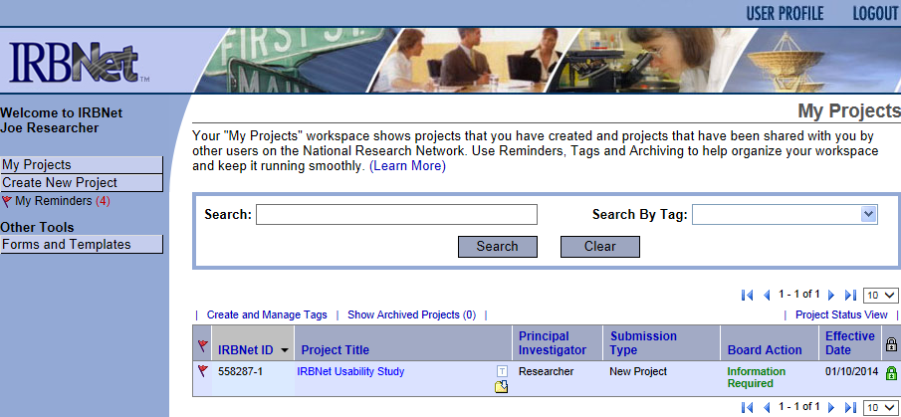
0

- Select the project you wish to modify.
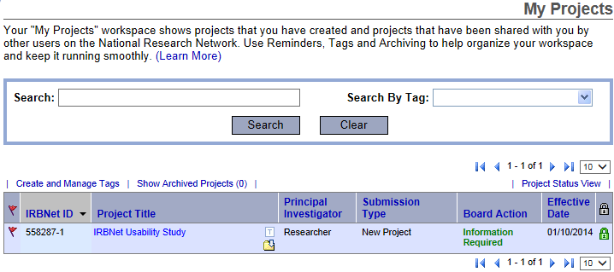

- You will be taken to this screen, click on the Project History tab.

- Click Create New Package at the bottom of the page.
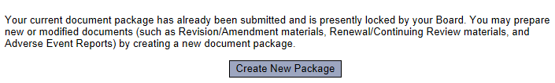

- Work in Progress (Not Submitted) will appear, click this to be taken to the Designer page.

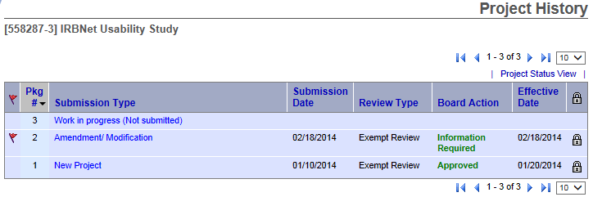
- From the drop list, you will select FORMS - Change in Protocol_Consent Form. Download this form, fill out all necessary fields and click Add New Document.

- From the drop-down Document Type box, select Amendment/Modification. Click Browse to find the document you wish to upload.
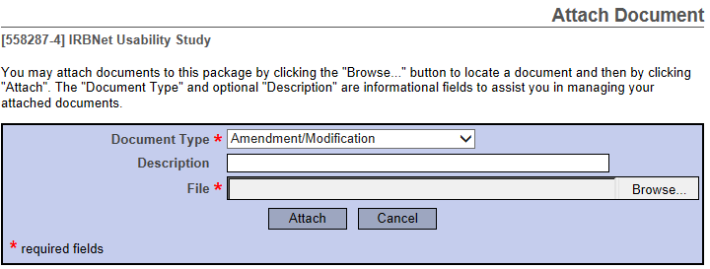

- Name the document and finish by clicking Attach. This will take you back to the Designer page where you can add more supporting documents if necessary.

- When all necessary documents have been uploaded, click Sign this Package on the left hand side of the screen.

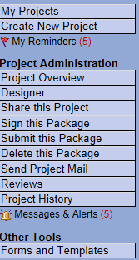

- At the Sign Package screen, indicate your project role and click Sign.

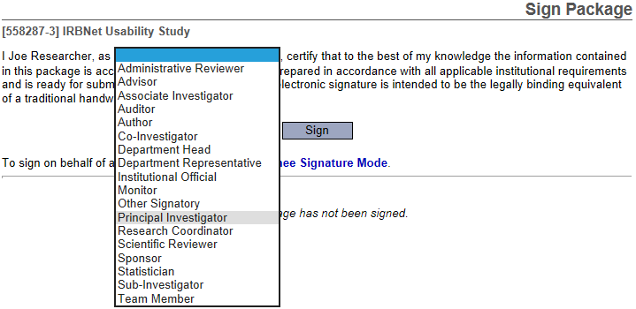

- Once signed, click Submit this Package on the left hand side of the screen.

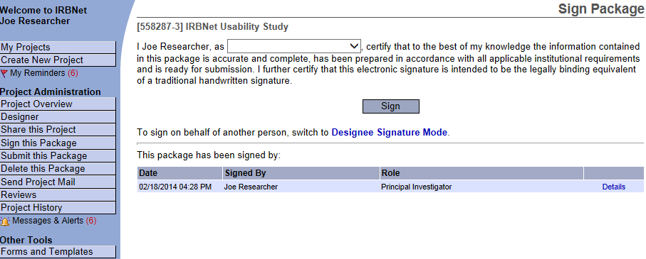

- Make sure Sul Ross State University Institutional Review Board is selected and click Continue.

- Select Amendment/Modification from the drop-down box and click Submit.

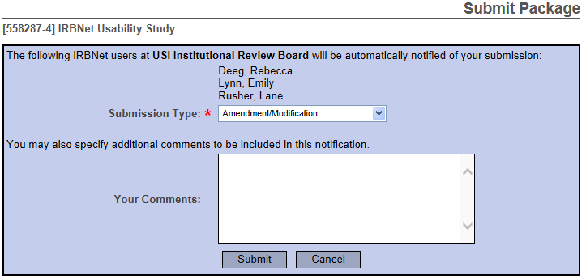

Renewing an Approved Study or Submitting a Progress Report
(Back to Table of Contents)
- Upon approval, your project will expire and/or be required to file a progress report on the date given by the IRB. You will receive an automatically generated email reminder from IRBNet when this date is approaching to allow you time to renew your project if necessary and/or file a progress report.

- Login to www.irbnet.org using your username and password.

- Select My Projects on the left side of the screen.

- Select the project you wish to renew.

- You will be taken to this screen, click on the Project History tab.

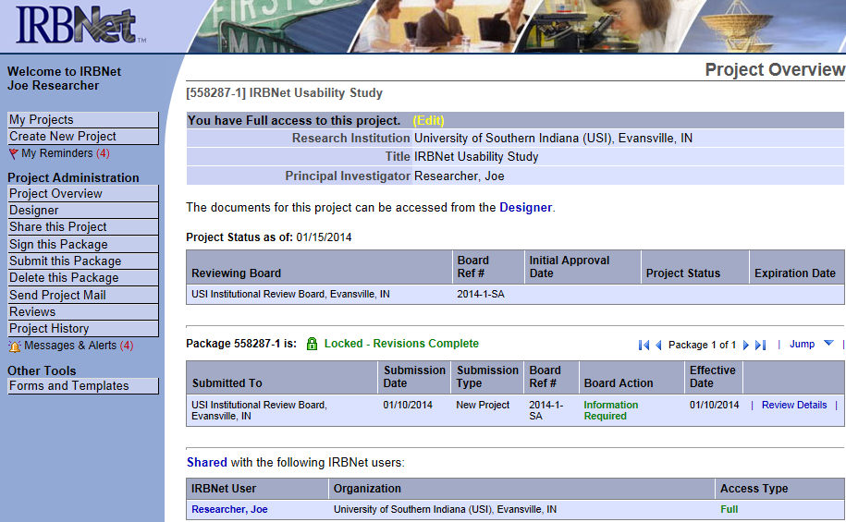

- Click Create New Package at the bottom of the page.

- Work in Progress (Not Submitted) will appear, click this to be taken to the Designer page.
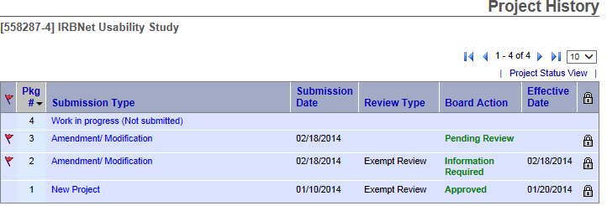

- From the drop-down box, select Continuing Review Form, download this, fill out all necessary fields, and click Add New Document.

- From the drop-down Document Type box, select Continuing Review/Progress Report. Click Browse to find the document you wish to upload.
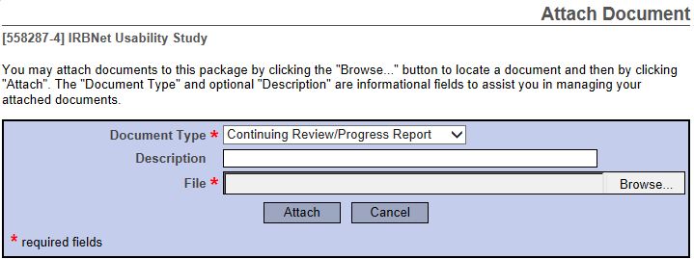

- Name the document and finish by clicking Attach. This will take you back to the Designer page where you can add more supporting documents if necessary.

- When all necessary documents have been uploaded, click Sign this Package on the left hand side of the screen.

- At the Sign Package Screen, indicate your project role and click Sign.

- Once signed, click Submit this Package on the left hand side of the screen.

- Make sure Sul Ross State University Institutional Review Board is selected and click Continue.

- Select Continuing Review/Progress Report from the drop-down box and click Submit.

Closing an Approved Study/Final Review
(Back to Table of Contents)
- When all data is collected and has been disseminated, you will need to submit a Final Report.

- Login to www.irbnet.org using your username and password.

- Select My Projects on the left side of the screen.

- Select the project you wish to renew.

- You will be taken to this screen, click on the Project History tab.

- Click Create New Package at the bottom of the page.

- Work in Progress (Not Submitted) will appear, click this to be taken to the Designer page.

- From the drop-down box, select Continuing Review Form, download this, fill out all necessary fields, and click Add New Document.

- From the drop-down Document Type box, select Closure/Final Report. Click Browse to find the document you wish to upload.
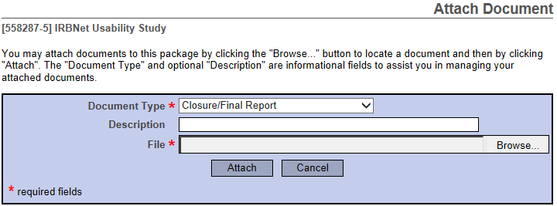

- Name the document and finish by clicking Attach. This will take you back to the Designer page where you can add more supporting documents if necessary.

- When all necessary documents have been uploaded, click Sign this Package on the left hand side of the screen.

- At the Sign Package screen, indicate your project role and click Sign.

- Once signed, click Submit this Package on the left hand side of the screen.

- Make sure Sul Ross State University Institutional Review Board is selected and click Continue.

- Select Continuing Review/Progress Report from the drop-down box and click Submit.

