Creating a Banner Requisition
July 2023

To create a requisition in Banner 9 type in FPAREQN on the opening screen. Once that has been done hit the Enter key.
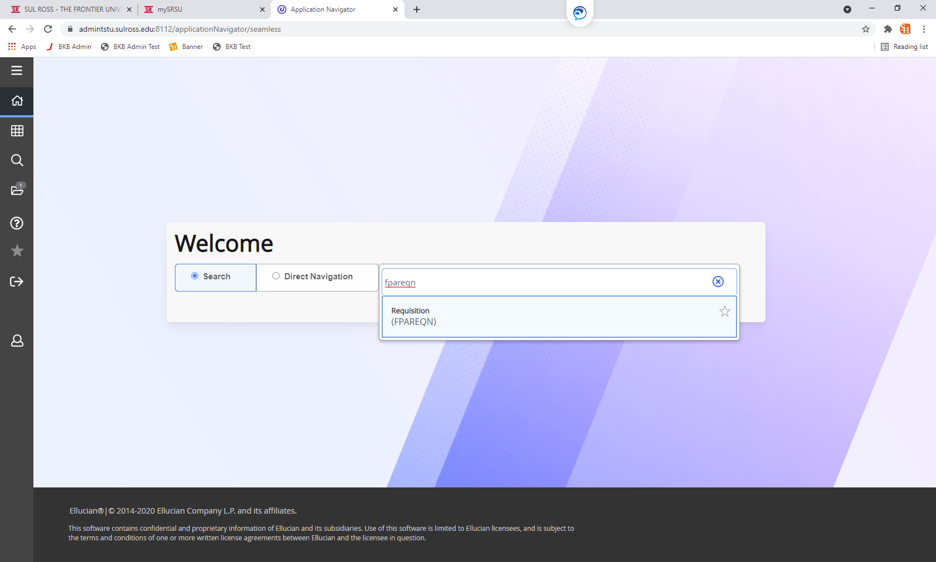

On the next screen, in the box next to Requisition, type in the word NEXT. Then click on the Go button on the righthand side of the screen.

The screen below will appear. In this section the
- Delivery Date
- Organization
- End Users Email
- Ship To
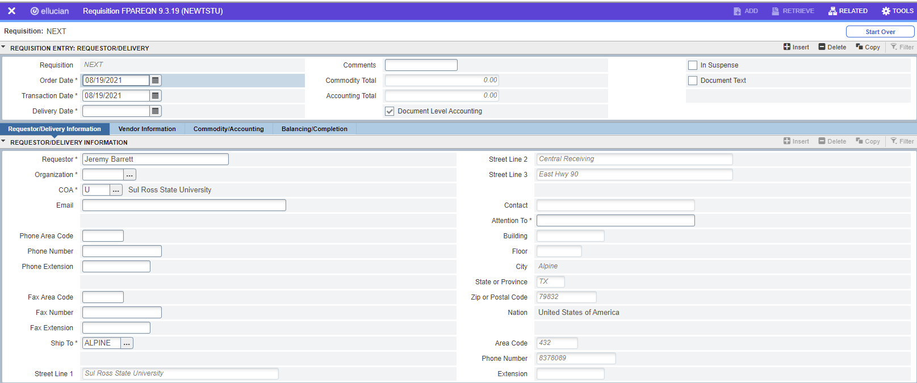
- Attention To
To choose the Delivery Date, click on the calendar icon to the right of the Delivery Date field. Choose the date the product/services are expected to be delivered. If you are not sure when the items will be delivered then choose a date that is 10 working days away from the current date.
The Organization will now need to be chosen. The Organization is how the end user’s department is identified. To do this simply click on the button with the three dots to the right of the Organization field.
This will bring up all the Organizations available in Sul Ross. To search for the end user’s department Org, click on the Filter button on the upper righthand side of the screen.
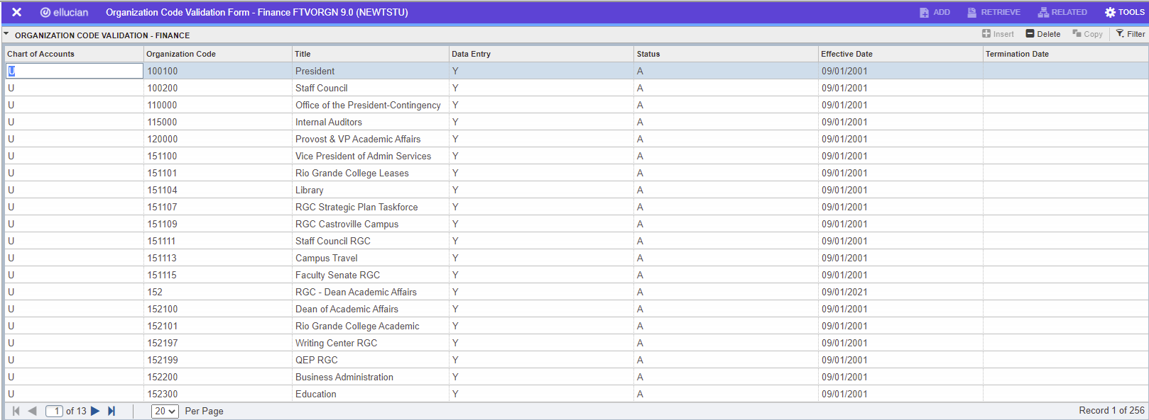
The following search boxes will appear once the Filter button is clicked. Simply enter in the parameter you wish to search under. When entering in a partial number or description in the field, the percentage sign will need to be added after the criteria. The first letter of the words will need to be capitalized, as Banner searches are case sensitive. Click on the Go button to execute the search.
The search should now pull the desired results. If it does not, click on the Filter Again button and try searching again. If one of the results that appears is the desired result simply double click or click the select button on the bottom right-hand side of the screen.
Once the Organization has been populated, fill out any additional pertinent information on this screen, such as the Email and the Attention To field. Once those fields are complete click on the down arrow on the bottom left-hand side of the screen to go to the next section.
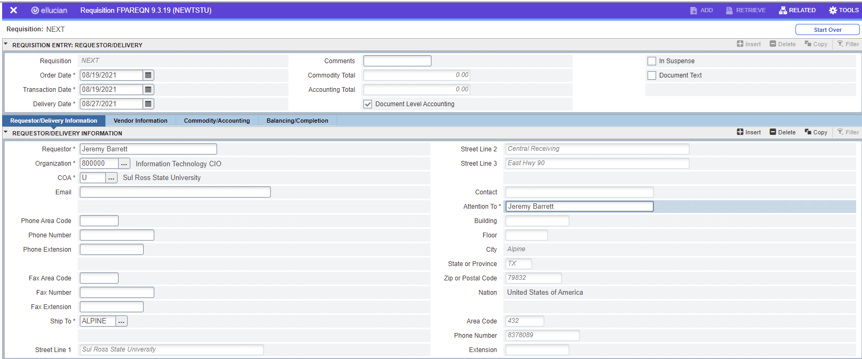
This will bring the end user into the Vendor Information screen. To select a vendor, click on the button with the three dots next to the Vendor field.
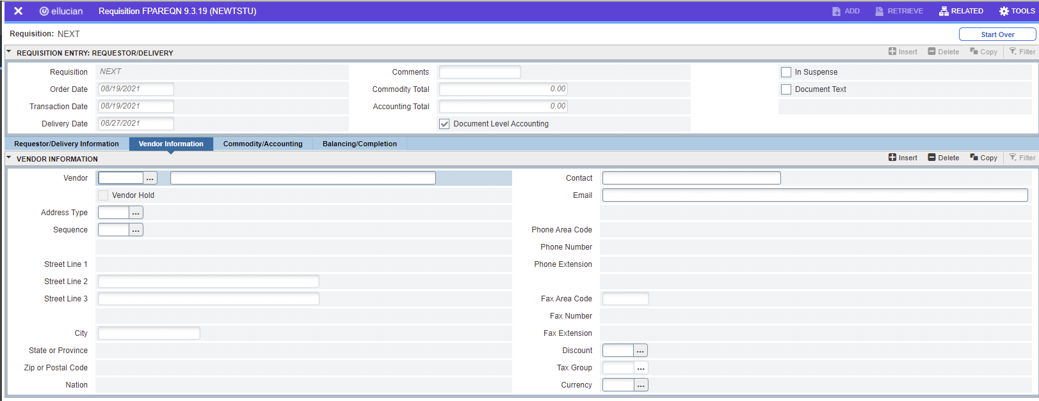
The following box will appear. To find vendors click on the Entity Name/ID Search (FTIIDEN).
Once in this screen ensure that the cursor is in the Last Name Field since that is where the search is performed. Remember Banner is case sensitive.
Type in the name of the vendor with the percentage sign after. If only part of the name is known, then type in the part that is known with a percentage sign before and after. Once this is done click the Go button on the right-hand side of the screen.

The search results will then populate. Highlight the vendor that is needed and double click on the name or choose the select button on the bottom right-hand side of the screen to select the vendor. If the vendor does not appear click on the Filter Again button to search with different parameters.
The vendor information will populate.
****If a vendor is not in Banner contact Blanca Padilla at blanca.padilla@sulross.edu to get the vendor set up in Banner. You’ll want to have a recent W9 from the vendor to help move the process along. Once this is complete, user the down arrow in the bottom left-hand corner to move to the next screen.
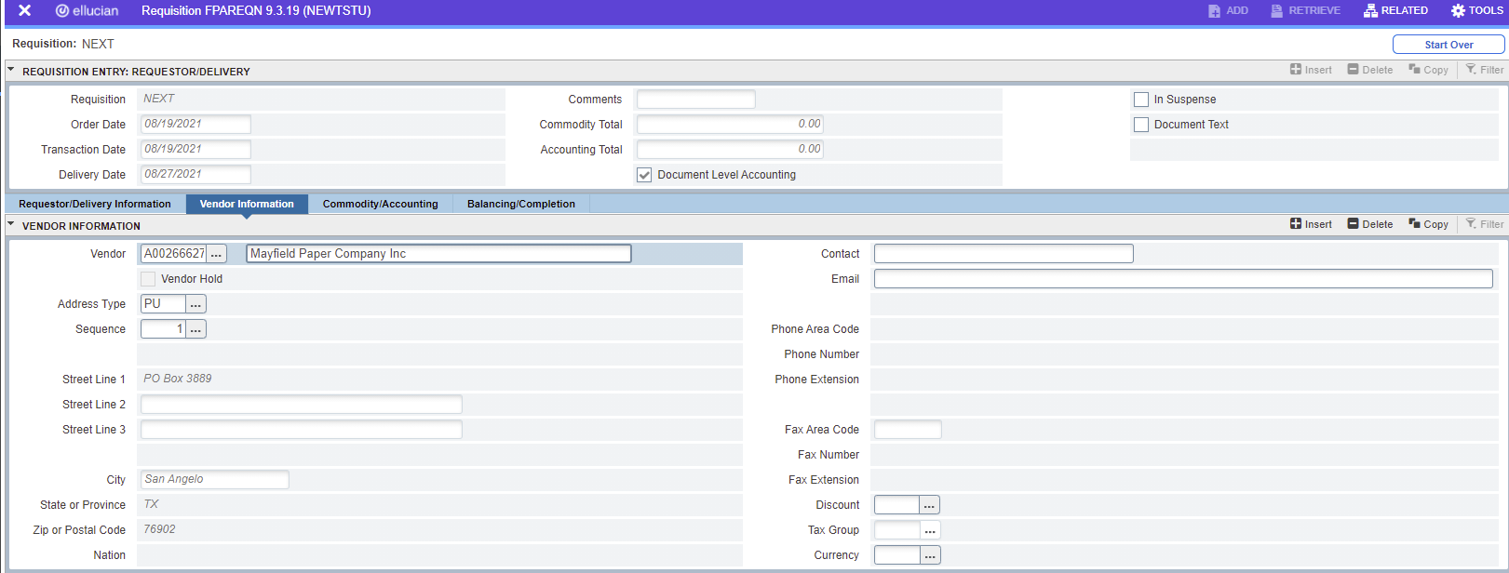
Document Text is text that will print out on a Purchase Order that pertains to the entire order. To add Document Text, click on Related and then on the menu that appears click on Document Text.
The following screen will appear. Click on the Go button.
Start entering text on each line. To navigate to the next line, click the down arrow. If text needs to be included but not printed on the PO uncheck the Print box on the right-hand side. Once complete, click the blue Save button on the right-hand bottom corner of the screen. Click the white X on the upper left of the screen to exit.
This is the screen where an end user will enter in the items that are being purchased and the FOAP used to pay for the items. To start, ensure that the cursor is in the Description field.
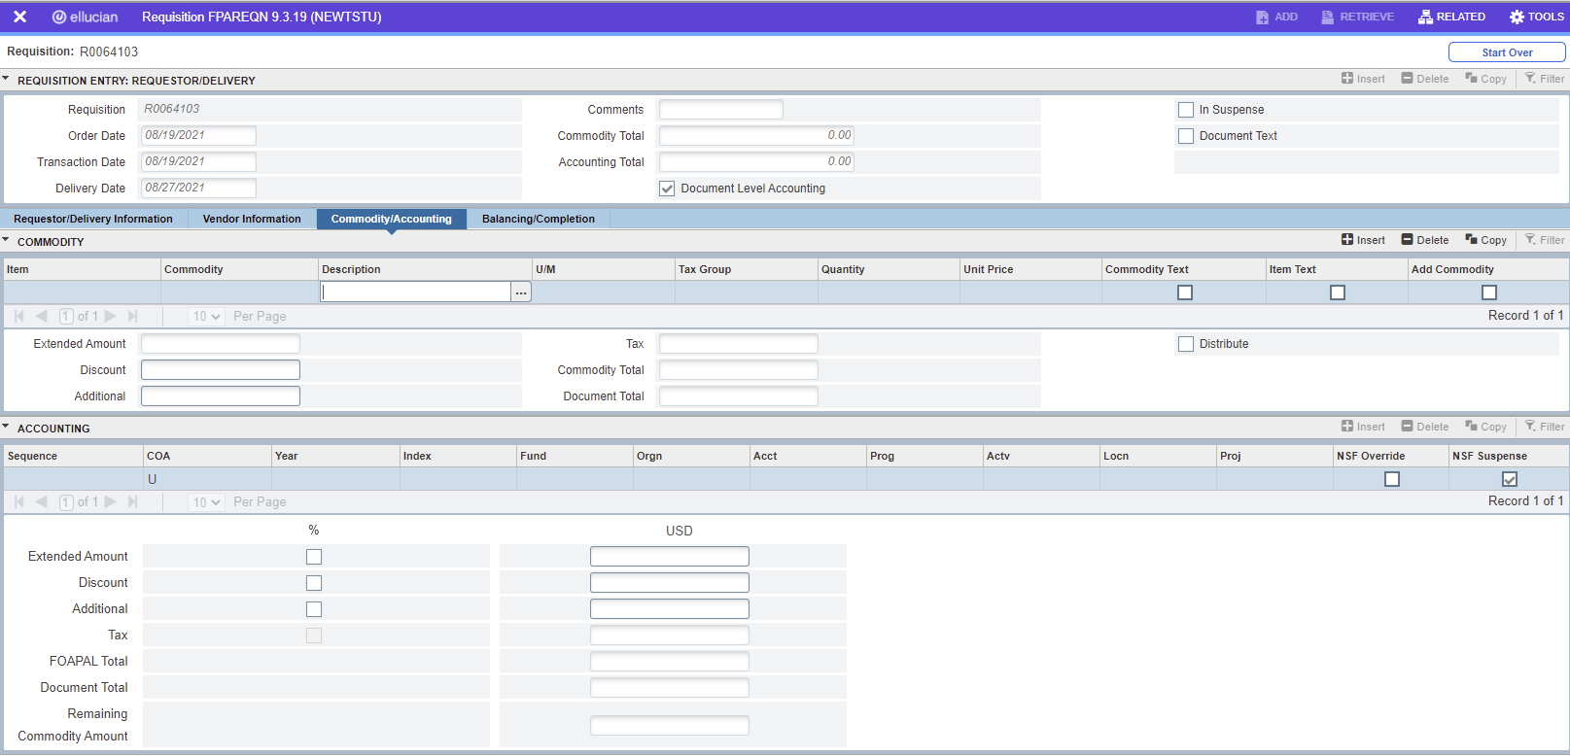

From here enter in the Description, the Unit of Measure, Quantity, and Unit Price. Once those are entered, using the Tab key, tab through until the Extended amount populates. Once this is completed, use the down arrow at the bottom left of the screen to move down to the Accounting section.
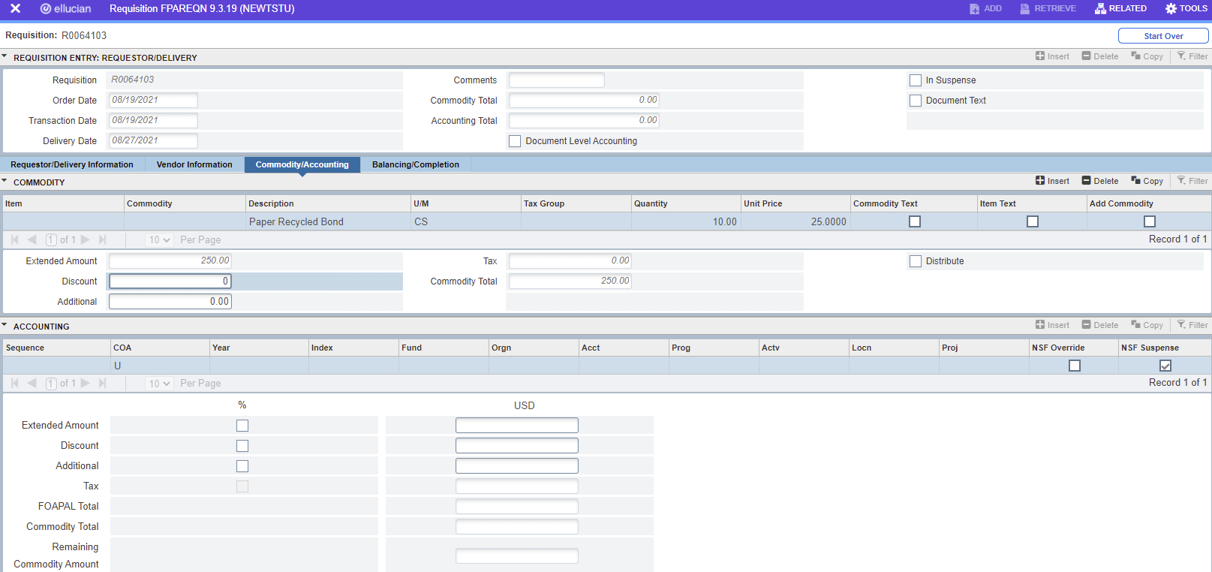
Item Text is information for the individual line items. To add Item Text, click on Related and then from the menu that appears click on Item Text.
The following screen will appear. Click on the Go button.
Start entering text on each line. To navigate to the next line, click the down arrow. If text needs to be included but not printed on the PO uncheck the Print box on the right side. Once complete click the blue Save button on the right bottom corner of the screen. Click the white X on the upper left of the screen to exit.

The Accounting section is where the FOAP will be entered to pay for the items. Starting with the Fund field enter in the department Index, Fund, Orgn, Acct., and Prog. Once this is complete tab down to the Extended Amount field and enter in the total for the line in the Extended Amount.
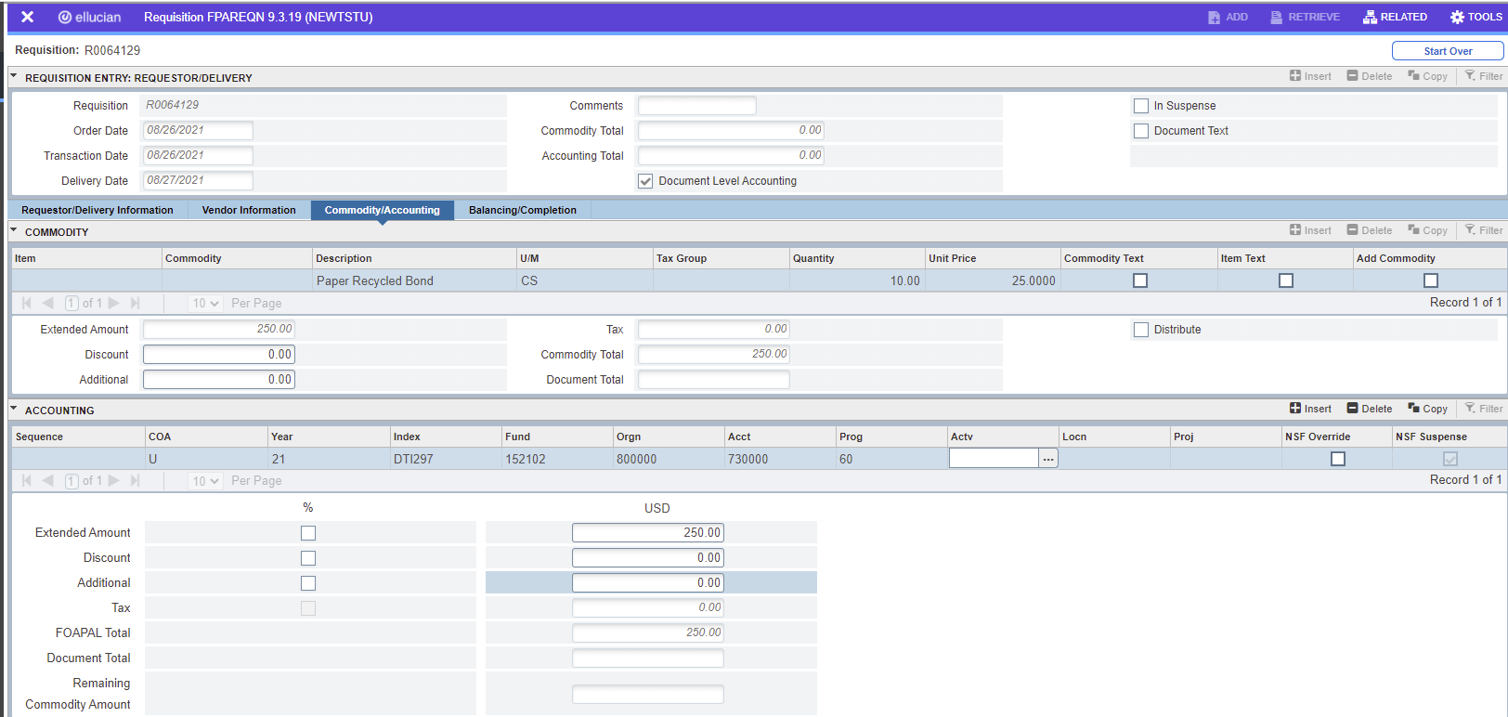

If more items need to be entered use the up arrow at the bottom left of the screen to go back and enter in more items by clicking on the line and pressing the down arrow key to open a new line.
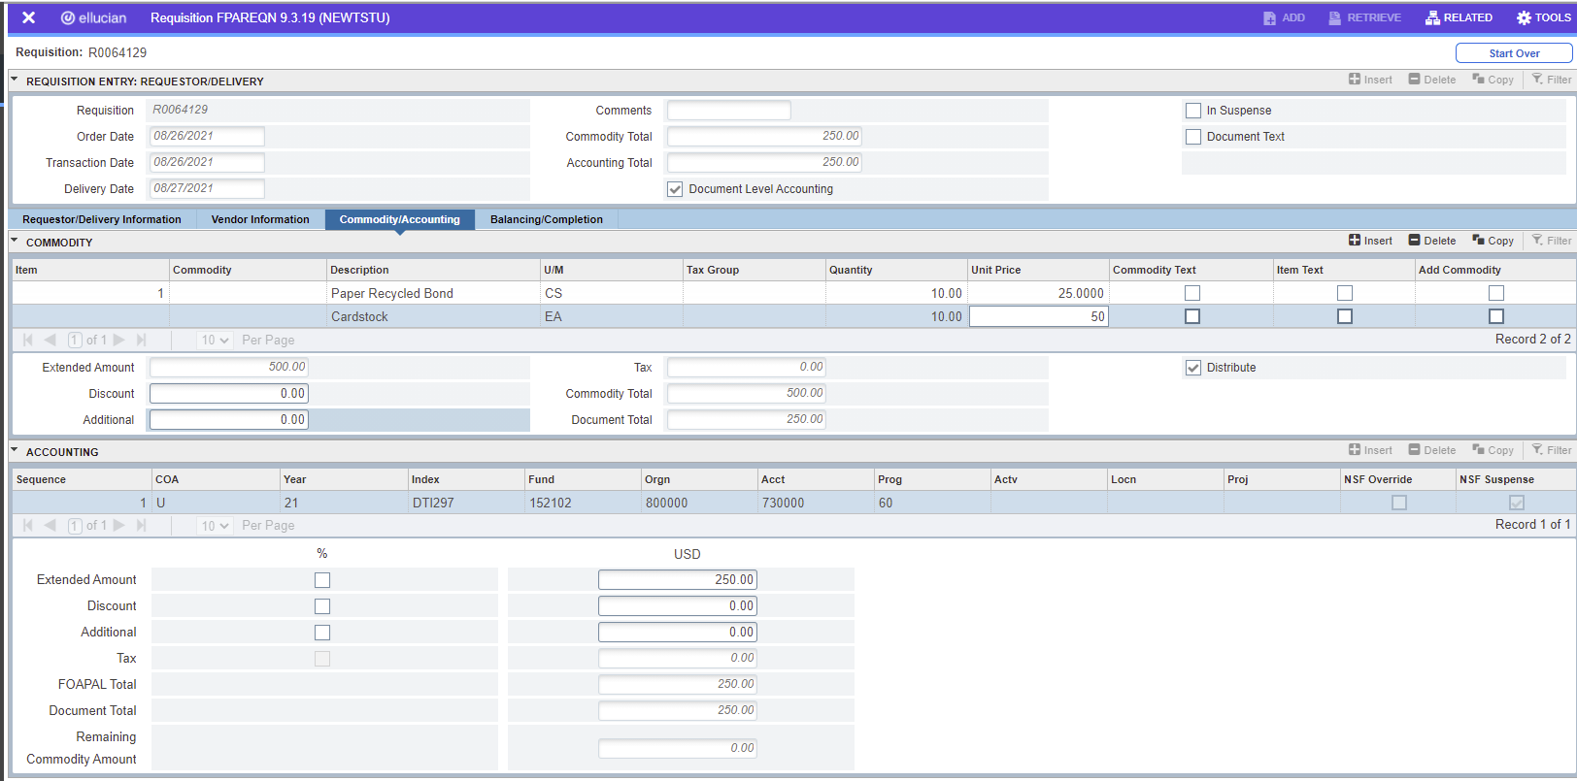
Using the down button at the bottom left-hand side of the screen proceed to the Accounting area to enter in the next FOAP. You’ll enter the Index Code number (six-digits) into the Index section (while on the U chart of accounts under the COA). The Index Code should then auto-populate the rest of the FOAP. You’ll just put in your own Account Code. Once the new FOAP is entered in tab to the Extended Amount field and enter in the total into the Extended Amount. Continue this method until all lines have been entered.
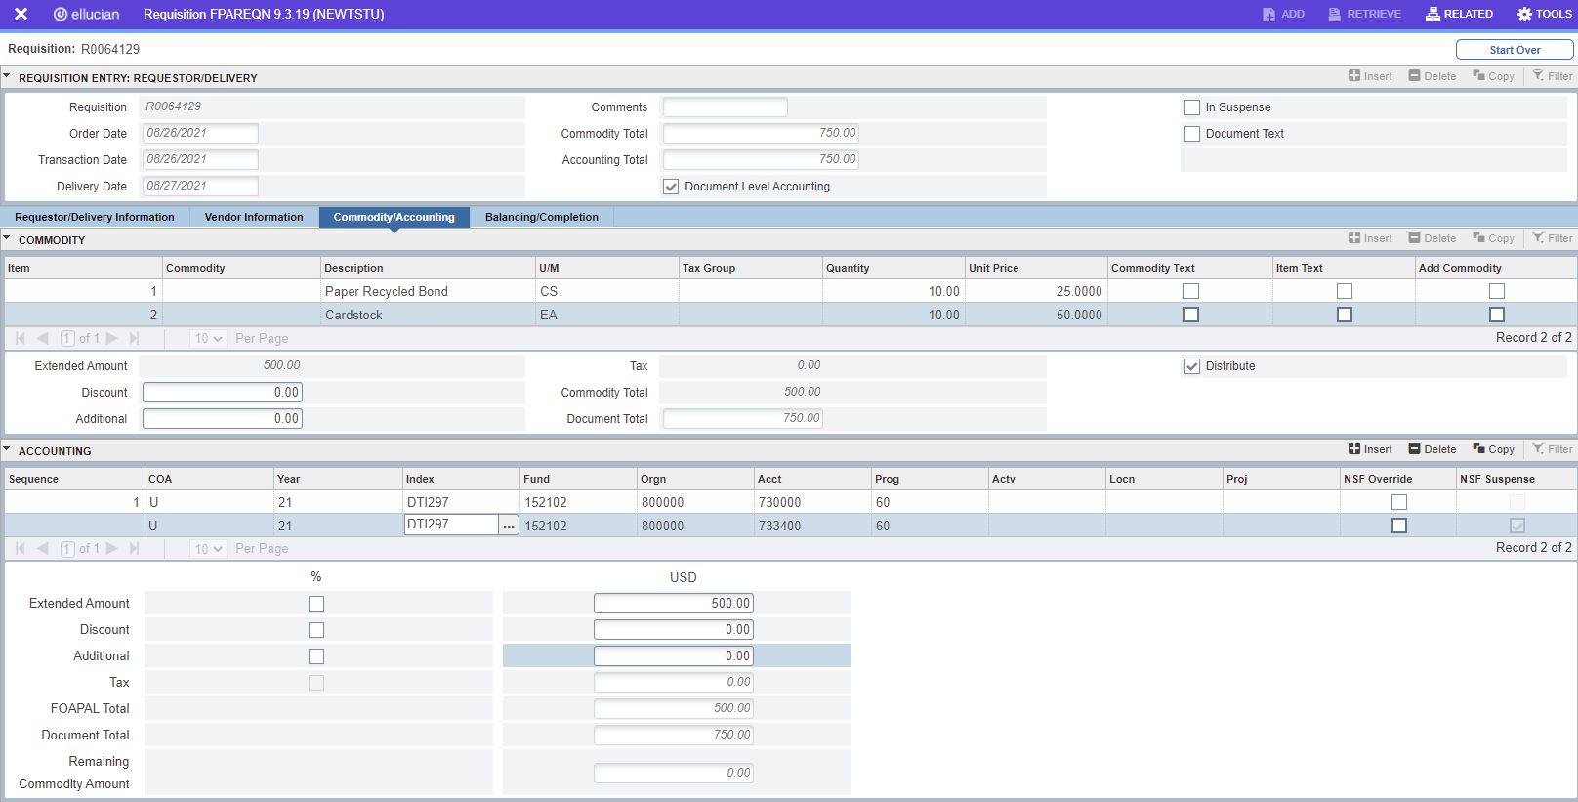
The next screen is the Balancing/Completion screen. Make sure that all the amounts in the Input, Commodity, and Accounting are the same and that the Status is showing BALANCED. If all is balanced, click the Complete button to finish the Requisition.
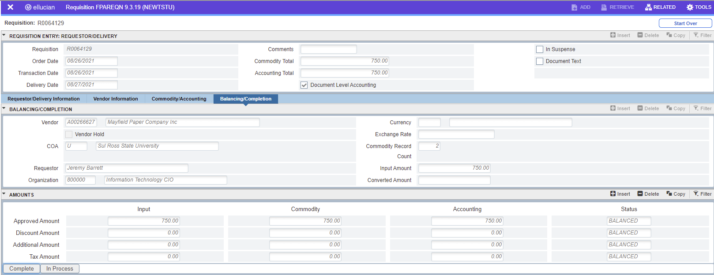
On the next screen on the right side a message will appear showing that the Document has been completed.

If there are any further questions or need additional direction, please contact one of the following:
Kim Tibiletti Purchaser I (936-294-1941) klt063@shus.edu
Katie Luedke Purchaser II (936-294-4673) Kaitlynn.luedke@sulross.edu

