**INSTRUCTIONS ON HOW TO PROPERLY FILL OUT INVENTORY SHEETS**

**PLEASE READ**

It’s that time of the year again to conduct a physical inventory of capital equipment. Please follow these instructions as they will help you understand what information is needed in each column.  
  
If there are any questions please feel free to contact Chuy Spencer ext. 8276 or [**jspencer@sulross.edu**](mailto:jspencer@sulross.edu)**.**

The inventory sheets consist of a cover page and the numbered inventory sheet(s) that correspond to your department.

* The cover page – should include the names of the team conducting the inventory (at least 2 persons-not including the property custodian.)
* **All** inventory sheets – must be signed by the property custodian (head of department)

Make sure the property custodian signs under the property custodian space and NOT the *property* *manager* space.

All inventory sheets must be complete. An incomplete inventory will not be accepted and will be returned to the property custodian (head of department) for completion, see APM 3.05.

Attached forms include: Transfers (temporary & permanent), Add-Ons, Deletion Request, Authorization to Remove Equipment Off Campus and Lost or Stolen Property Report. Some of these forms are available to you on the Accounting Services page on the Sul Ross website.

**Return Inventory by Due Date**

When returning your inventory sheets it should have attached some of these forms mentioned above as part of your packet to account for any discrepancies and/or document changes you declare it took place. Please return all completed inventory sheets by due date as University is attempting to certify “inventory is complete” in a specific time frame. Make sure **each** inventory sheet is signed and dated by department head, not secretary or team individual conducting inventory.

**Send original to: Accounting Services Box C-500 and retain a copy for your department records for future reference by April 22, 2022.**

**Below is a description of what each column & what information it should contain:  
  
Inventory / Asset Property Number**: This number is supplied by us; it is the 6 digit inventory / property asset number of the item. In most cases it will/should be located in the front of the property where it is visible. Computers and laptops may have asset property number located on backside. Make sure to check whether the inventory asset number matches the description of the items and the serial number corresponds. *Asset number or PRN (Property Record Number) 6-digit example > 052615*   
See page 7 of instructions for examples of what numbered tags look like.

**Description of Item**: The item identified must match the inventory sheet description… double check info… such as – make, model, series, watts, power, *serial number*, etc., against the item. If you discover that certain description information should be changed to better describe, please provide information… so we may further evaluate and make any changes.

**Serial Number:** The serial number is not a sticker provided by Sul Ross. It is provided by the manufacturer. Usually the manufacture affixes the serial number on the backside of item. On a metal plate or placard; find it on the back side or sometimes on the underside. This manufacturing label should indicate the words *Serial Number* or if abbreviated as *S/N* or *serial #*. You must double check to make sure the inventory description and *serial number* matches the item on your inventory sheet. If the serial number column is blank and the item has a mfg. serial number, please provide us with that number.

**Condition:** Please use your sound judgment or ask department head (property custodian) to correctly categorize the condition of the item:  
G: good  
F: fair  
P: poor  
Do not leave blank

**User:** The user/purpose column requires you to enter in the name of the person who is responsible user. Please supply us with the first initial and the last name. If there is not one specific person using the item, the item will be assigned to the property custodian (head of department), so please supply us with their first initial and last name. Do not leave blank.  
  
*Example: User is Molly Rogers; the correct entry is* ***M Rogers*  
  
Location (Building and Room#):** Please provide us with the correct building and room number where the item is PHYSICALLY located. If the item is not in a specific building or room please contact the property custodian (head of department) and determine where the items’ location should be. If you are still unsure about the item location, please do not leave it blank. Contact us so we can help you determine its floor plan location. *Do not leave blank.*

The following are examples to fill-in column (Bldg. & room and USER)  
Example: PP301 K Smith  
 WSB302D S Jones  
 MAB308 M Garcia

**Located by (initials):** The initials should be by the person(s) ‘team’ who physically located the item(s), there should be at least 2 initials*. Do not leave blank*.

**Previous Year:** this column is provided (informational purpose only), either it is blank or with historical information (where item was last inventoried). For CURRENT year physically inventory item condition, building/room and user. If there is no *previous year information,* just leave it blank. This is the *only* column that can have blank spaces.

**DM:** The DM column is to indicate that equipment has been reported missing (19). Item(s) will be on inventory for 2 years. If item(s) is/are found, please complete appropriate information on that line.

**FORMS (attached)**

**Add-ons Form –** This form should be used when you discover property or asset number is not listed on your inventory sheet. Indicate how this equipment got acquired i.e. as new arrival purchase, never been counted, obsolete, got moved or transferred to your area without notifying Property & Inventory. Please use Add-on form to add all equipment or property numbers that do not appear on your inventory sheet.

Indicate on the Add-on form: Asset number, description, serial number, *condition*, bldg/room/user and team inventory *initials* (similar to inventory sheet).

Example: Asset No. 05XXXX Laptop Latitude E5520 Serial No. V664H91 BAB101 M Rogers  
  
Include all furniture that has an asset tag number(s) or obsolete (out of service) items with old brass asset numbering. Property & Inventory will examine reported Add-on information and make proper changes.

**Transfer Request Form –** This form should always be used for any property moved from dept. to dept. The form should be signed by both parties agreeing to transfer transaction and copy conveyed to Inventory dept. to get transaction changed on inventory. The reason why some equipment still appears in your inventory, but you know equipment is no longer in your department – is because Property & Inventory was never notified (form submittal) that equipment was physically removed or a transfer took place. Repeats can be avoided by notifying & filling proper form, so that prompt updating can reflect any transfer adjustments. It is the responsibility of the department head who originally has equipment to file & archive documentation that agreed transaction took place.   
In the case that OIT is picking-up faulty equipment and replacing with other, final responsibility rests on department head to notify inventory department, when OIT equipment replacement transaction took place. A transfer form must be used, if OIT adds or removes computers, printers or any other data processing equipment from your area. A transfer form agreement is not complete until notification has been received at Property & Inventory from both parties (transferor and transferee). However OIT also assumes responsibility for any incomplete transfer between parties and assumes physical possession for pending equipment to surplus or reassignment.

**Deletion Request Form –** This form should be used to request equipment removal, delete from service or no longer needed to be picked-up - to surplus storage. The department head must submit a deletion request to the Property Manager for approval. Upon approval Property & Inventory will make arrangements to remove as surplus and in exchange, Inventory Dept. will give a receipt. Again, it is important to file this form with – Property & Inventory Dept. and keep a copy for your records. We will no longer accept indications on annual inventory sheets that equipment was *picked-up as surplus* unless documentation Deletion form(s) are properly attached. We cannot remove a line item off your inventory if it is not clear that Property & Inventory has not taken possession.

**Lost or Stolen Report Form –** This form should be used if you discover an item has been stolen and should immediately be reported to campus police. In the case of discovering a missing item from your annual inventory, the Property Custodian must file a “Lost or Stolen Report”. Two copies of the report go the Property Manager who submits one copy to the UDPS for formal investigation. State law requires that when State property disappears as a result of negligence of the agency employee entrusted with property’s safekeeping, such person may be peculiarly (financially) liable to the State of Texas for the loss.

**If an item is missing, lost or *cannot be found*.**

Complete inventory sheet as “cannot locate”. Property & Inventory department will research with other departments, add-on filings, surplus storage etc. If item still cannot be found, then a Lost or Stolen Property Report will be completed to declare missing property and to indicate that is uncertain of its location and will continue to make efforts to search until property is found or resolved.

#### Authorization To Remove Equipment Off Campus Form - All laptops, I Pads, portable projectors, cameras (with a tracking asset number), etc. Departmental Equipment that is not on-hand during an inventory and/or is being used off campus require an “Authorization to Remove Equipment Off Campus” form. This requirement is to comply with State Property Accounting procedure. By preparing this form during our Physical Annual Inventory period, it will also ensure department & university accountability and employee accepts fiduciary responsibility if equipment is not returned by due date.

#### It is each state employee’s responsibility to use property only for state purposes and to exercise reasonable care for its safekeeping. Sul Ross employees who are entrusted by Property Manager to remove property off campus in pursuit of job duties are allowed when the person provides a signed and dated receipt to Property Manager. This said FORM is attached.

**FREQUENT ENCOUNTERS**

**DM (Disposal Method)** – If item has been declared lost/missing or reported stolen (DM19 missing).

**The item was stolen?** Please provide us with a copy of the **STOLEN REPORT** if previously filed; if one has not been filed please do this as soon as possible, as stolen report should be done immediately after the item has been discovered as stolen.

**The item is lost/missing?** You must fill out the **LOST/STOLEN** report form (attached).

Please contact the head of department or user of the item to determine where the item should be. If item is not found, you must fill out a **LOST/STOLEN report** form (attached). Missing items are treated like stolen items, except we will continue to make efforts to search until property is found or resolved. Item cannot be removed from your inventory until two years elapse and/or only until authorized by State Comptroller.

**The item was transferred?** There should have been a **PROPERTY TRANSFER** sheets filled out by the both departments involved in the transfer and should include signatures. Please provide us with a copy of the transfer sheet. If you have not done so, please fill one out and contact the department where the item was transferred to and have them fill one out as well, signatures are required.

**The item is broken/ non-working?** Please note in the condition column as poor and notify us so we can pick up the item. Use the Request for Deletion form.

**The item has been picked up by our department?** Please attach a note stating the item was picked up by our department and supply a copy of the pick-up form (deletion request) as well.

**The item is not listed in your inventory sheet?** Please locate the *Add-On Sheet* and add the items that are not listed in your inventory sheets. The items that you add should have a property number on them. Make sure you supply us with the correct property number (6 digits), serial number and a correct description of the item.

**Example situation: Accounting has a Dell computer not listed in their inventory… they would:**

**Locate the property number, serial number, make and model on the computer and enter it into the Add-on sheet as indicated below:**

**Inventory# Description Serial# Location User**

**05XXXX Computer Dell 7010 BGX000 BAB204 S. Ryan**

**THE MOST IMPORTANT BIT OF INVENTORY INFORMATION:  
BUILDING, ROOM & USER**

MOBB212 N ACOSTA

*FAB203B J SAWYER*

**SUL ROSS – TYPES OF TAGS** 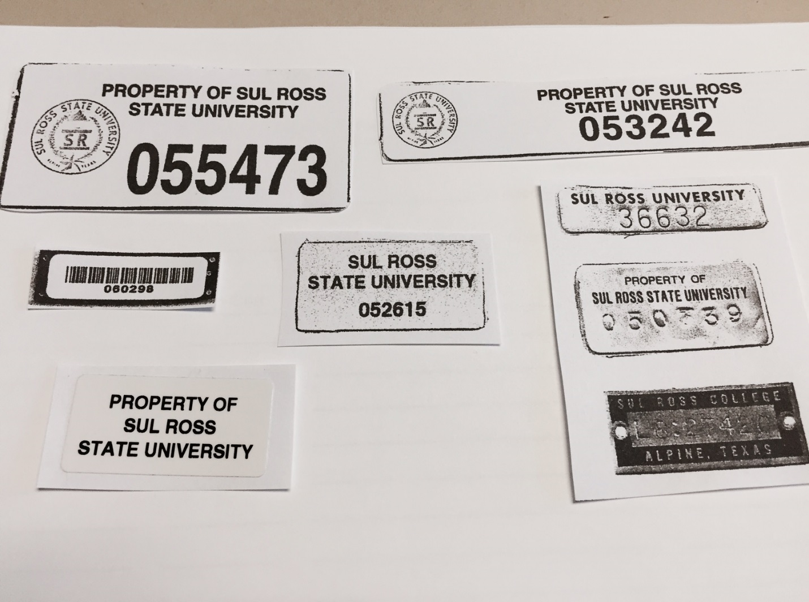

Request for Permanent Property Transfer

Sul Ross State University

Date:

From Department: Bldg/Rm#/User

(Transferor)

To Department: Bldg/Rm#/User

(Transferee)

|  |  |  |  |  |
| --- | --- | --- | --- | --- |
| Inventory No. |  | Description of Item |  | Serial No. (If any) |
|  |  |  |  |  |
|  |  |  |  |  |
|  |  |  |  |  |
|  |  |  |  |  |
|  |  |  |  |  |
|  |  |  |  |  |
|  |  |  |  |  |
|  |  |  |  |  |
|  |  |  |  |  |
|  |  |  |  |  |
|  |  |  |  |  |

Reason for Transfer:

Property Custodian's Signature Property Custodian's Signature

(Transferor) (Transferee)

Property Manager's Signature

**DELIVER COPY TO: PROPERTY & INVENTORY**

Rev 10/15

Temporary Property Transfer

Sul Ross State University

Date:

From Department: Bldg/Rm#/User

(Transferor)

To Department: Bldg/Rm#/User

(Transferee)

Length of Loan: ­­­­­­­­­­­­­­­­­­­­­­

|  |  |  |  |  |  |
| --- | --- | --- | --- | --- | --- |
| Inventory No. |  |  | Description of Item |  | Serial No.(If any) |
|  |  |  |  |  |  |
|  |  |  |  |  |  |
|  |  |  |  |  |  |
|  |  |  |  |  |  |
|  |  |  |  |  |  |
|  |  |  |  |  |  |
|  |  |  |  |  |  |
|  |  |  |  |  |  |
|  |  |  |  |  |  |
|  |  |  |  |  |  |
|  |  |  |  |  |  |

Reason for Transfer

Property Custodian's Signature Property Custodian's Signature

(Transferor) (Transferee)

**DELIVER COPY TO : PROPERTY & INVENTORY**

Rev 10/15

**Lost or Stolen Property Report**

**Sul Ross State University**

Date:

Department: Account No.:

|  |  |  |  |  |  |
| --- | --- | --- | --- | --- | --- |
| Inventory No. |  |  | Description of Item |  | Serial No. (If any) |
|  |  |  |  |  |  |
|  |  |  |  |  |  |
|  |  |  |  |  |  |
|  |  |  |  |  |  |
|  |  |  |  |  |  |
|  |  |  |  |  |  |

Date & Location Last Seen:

Date & Time reported to University Dept. Public Safety: __________________________

How was the item lost?

Original Cost of Item:

Who was responsible for the item? __ ___

Explanation & Recommendation:

RETURN TO: PROPERTY & INVENTORY

_____

Property Custodian

**PROPERTY DELETION REQUEST** Page ____ of _____

Date _____________

Sul Ross State University

Alpine, Texas

Request your approval to delete the following item(s) listed below from the Departmental inventory for the reason(s) stated:

|  |  |  |  |  |  |  |  |  |
| --- | --- | --- | --- | --- | --- | --- | --- | --- |
| Inventory  Number |  | Description |  | Serial Number |  | | Reason for  Deletion | |
|  |  |  |  |  |  | |  | |
|  |  |  |  |  |  | |  | |
|  |  |  |  |  |  | |  | |
|  |  |  |  |  |  | |  | |
|  |  |  |  |  |  | |  | |
|  |  |  |  |  |  | |  | |
|  |  |  |  |  |  | |  | |
|  |  |  |  |  |  | |  | |
|  |  |  |  |  |  | |  | |
|  |  |  |  |  |  |  | |

Disposition:

Dept: ________________________________

______________________________ ______________________________

REQUESTED BY: APPROVED:

PROPERTY CUSTODIAN PROPERTY MANAGER

Date: Date:_______________________

**ADD-ONS**

**(ADD ANY CAPITAL EQUIPMENT THAT SHOULD BE ON YOUR INVENTORY)**

**Capital Equipment Inventory Sheet**

**Sul Ross State University**

***A Member of the Texas State University System***

**Alpine, Texas 79832**

**Page __ of ___ Pages**

**Department _________________**

|  |  |  |  |  |  |  |
| --- | --- | --- | --- | --- | --- | --- |
| Inventory  Number | Item  Description | Serial  No. (if any) | Condition  (G)ood  (F)air  (P)oor | Location  (Bldg.  & Rm#) | User | Located  By  Initial(s) |
| 055555 | HP Tower | CN12345678 | G | BAB301 | J Ray | JS/BP |
|  |  |  |  |  |  |  |
|  |  |  |  |  |  |  |
|  |  |  |  |  |  |  |
|  |  |  |  |  |  |  |
|  |  |  |  |  |  |  |
|  |  |  |  |  |  |  |
|  |  |  |  |  |  |  |
|  |  |  |  |  |  |  |
|  |  |  |  |  |  |  |
|  |  |  |  |  |  |  |
|  |  |  |  |  |  |  |
|  |  |  |  |  |  |  |
|  |  |  |  |  |  |  |
|  |  |  |  |  |  |  |
|  |  |  |  |  |  |  |
|  |  |  |  |  |  |  |

**SUL ROSS STATE UNIVERSITY**

**AUTHORIZATION TO REMOVE EQUIPMENT OFF CAMPUS**

This form is to be used when removing SRSU Controlled/Capital equipment from any campus location for official use.

**INSTRUCTIONS: 1) *Complete*** this form and retain a copy for your records.

1. ***Route*** and ***Obtain*** authorized signatures.
2. ***Submit*** the ***Completed ORIGINAL*** form to Property & Inventory.
3. ***Upon receipt of equipment*,** complete bottom portion and submit to Property & Inventory.
4. The **UNDERSIGNED REQUESTS** authorization to **REMOVE** from the campus of **Sul Ross State University** equipment listed below belonging to the **Department**
5. The **UNDERSIGNED CERTIFIES** that: The **purpose** for **equipment removal** constitutes **official** University business.

**PURPOSE**:

**LOCATION** (street address) of the removed equipment: **DATE** equipment will be **REMOVED** from SRSU Campus **DATE** equipment will be **RETURNED** to SRSU Campus

1. **The undersigned will exercise reasonable care and accepts fiduciary responsibility for the property taken off campus, and if negligently lost, stolen or damaged – Will replace or reimburse the University for the total or replacement cost of the property. I will surrender the property upon demand. Transfer or separation from SRSU and understand all property signed out must be made available for physical inventory at least once per year for the departmental Annual Physical Inventory.**
2. **A signed copy of this form must accompany the item while off campus and must be presented upon request if stopped by SRSU police.**

(RETURN DATE IS VALID FOR ONE YEAR. A NEW FORM MUST BE SUBMITTED IN EACH FISCAL YEAR)

|  |  |  |  |
| --- | --- | --- | --- |
| **INVENTORY ASSET TAG NUMBER** | **DESCRIPTION** | **SERIAL NUMBER** | **COST** |
|  |  |  |  |
|  |  |  |  |
|  |  |  |  |

**REQUIRED AUTHORIZED SIGNATURES**

**Person Removing Property (Print) Signature**

**Banner ID**

**Date**

**Authorized by Dept. Chair/Director (Print)**

**Signature**

**Date**

**DO NOT COMPLETE THIS BOX UNTIL THE EQUIPMENT HAS BEEN RETURNED TO SRSU CAMPUS**

**Item Returned to Dept./Office**  **Bldg. & Rm #**

**Person Returning Property (Print)**

**Signature**

**Date**

**Received by Witness (Print)**

**Signature**

**Date**

**Person by Dept Chair/ Director (Print)**

**Signature**

**Date**