**CITIBANK RECONCILIATION PROCESS**

Login to the Citbank website at the following link with your assigned User ID and Password:

<https://www.globalmanagement.citidirect.com/>

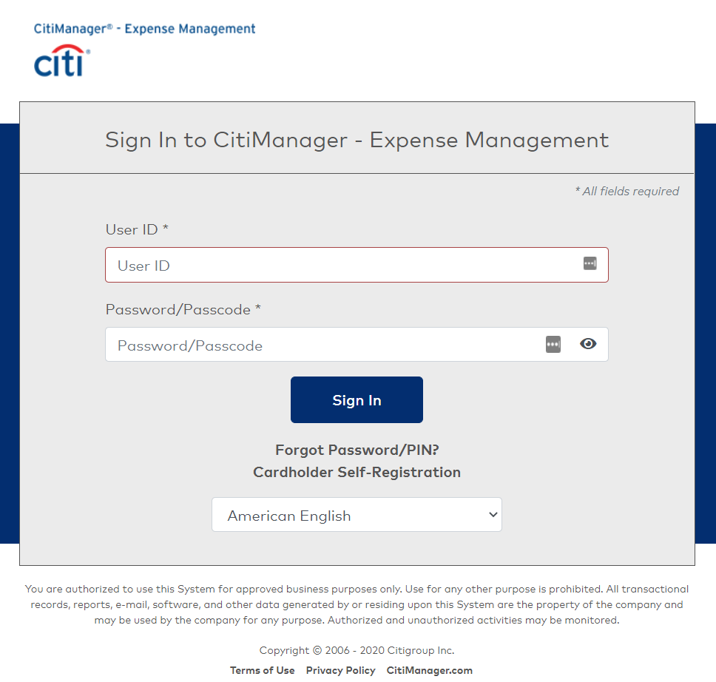

If you need assistance obtaining/registering a User ID and password please contact the SHSU Card Services Administrator at [srsupcard@shsu.edu](mailto:srsupcard@shsu.edu) .

The system will then ask you a challenge question. (See example below)

If this is the first time you have logged in to Citibank, you will be prompted to select 3 different challenge questions.

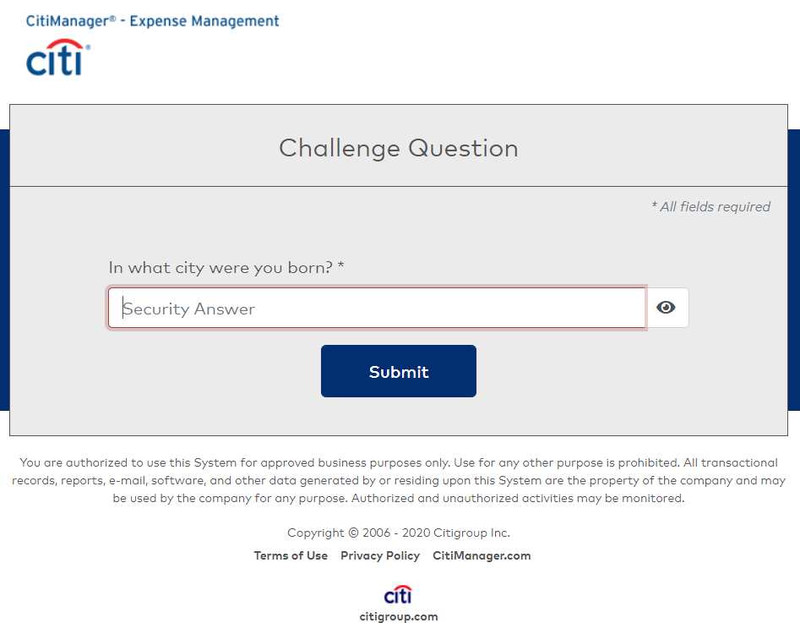

1. Once logged in the Expense Management Home Screen will be displayed   
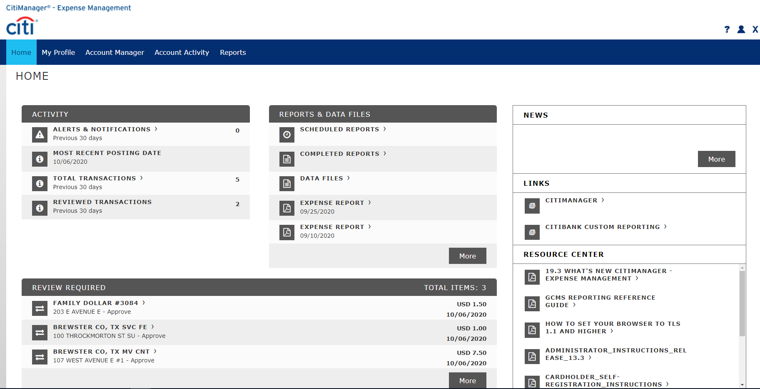

2. Click on the “Account Activity” tab and select “Transaction Summary”.  
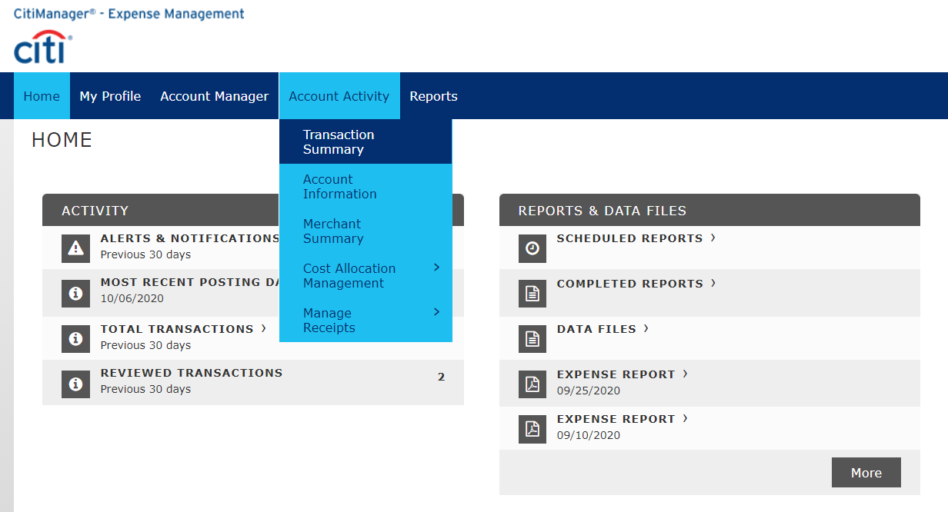

The Transaction Summary Screen will allow you to search for transactions completed on the P-Card within a certain date range or by a Date Type:

Date Rage: Range of dates “From and To” when transactions were made

Posting Date: Date Transaction posted to the Statement

Transaction Date: Date Transaction was made

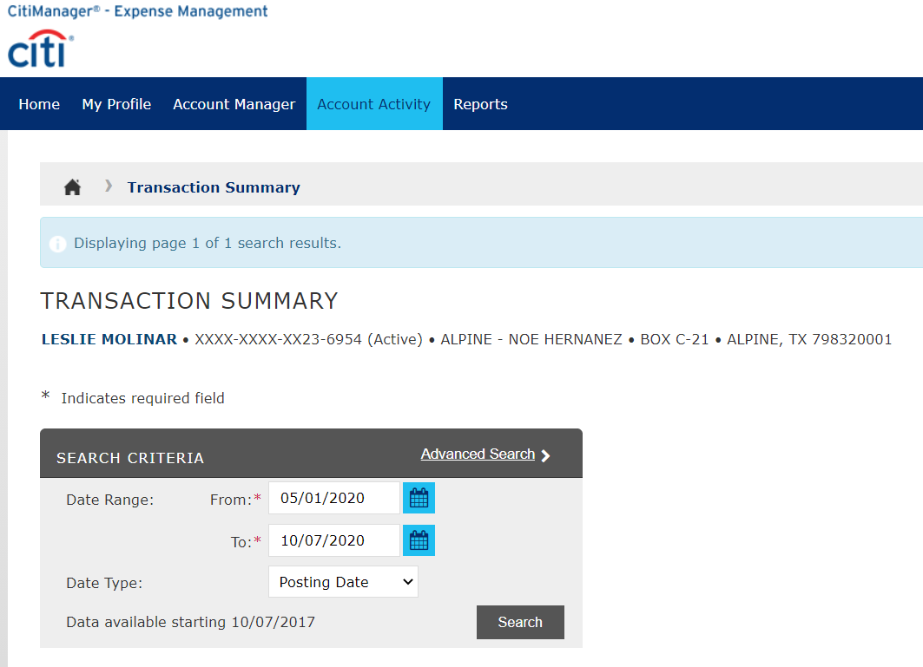

3. On the Transaction Summary Screen, under Search Criteria change the From and To date ranges to the appropriate dates for the current Statement Cycle (i.e. 8/4/2020 – 9/3/2020)

(Access the link for P-Card Reporting Cylces Periods)

<https://www.sulross.edu/sites/default/files//sites/default/files/users/docs/purchasing/pcard_fy21_report_cycle_draft_8-31-2020_003.pdf>

4. After you have entered the criteria, click the “Search” button. Transctions completed within the selected date range will be displayed.  
 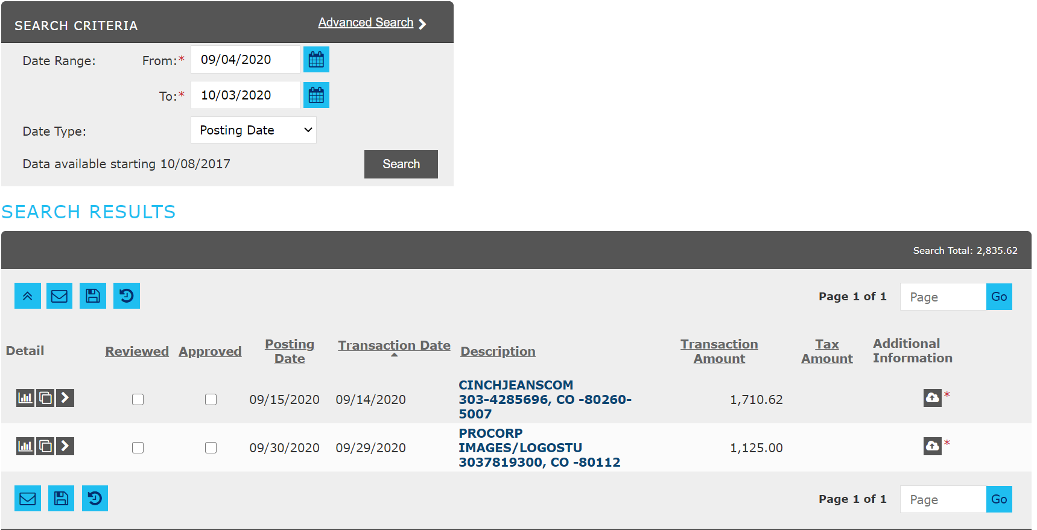

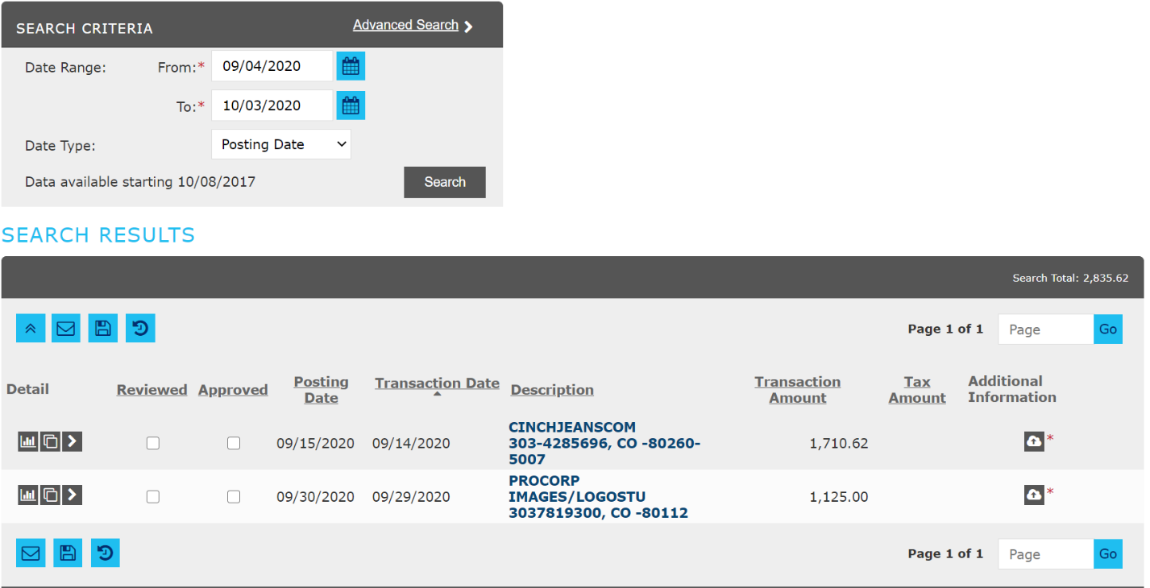  
5. Click on the  arrow under the “Detail” Column.

6. This action will open the line item to allow Accounting Details to be entered or selected for each expense.

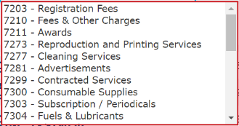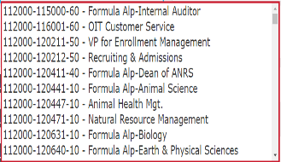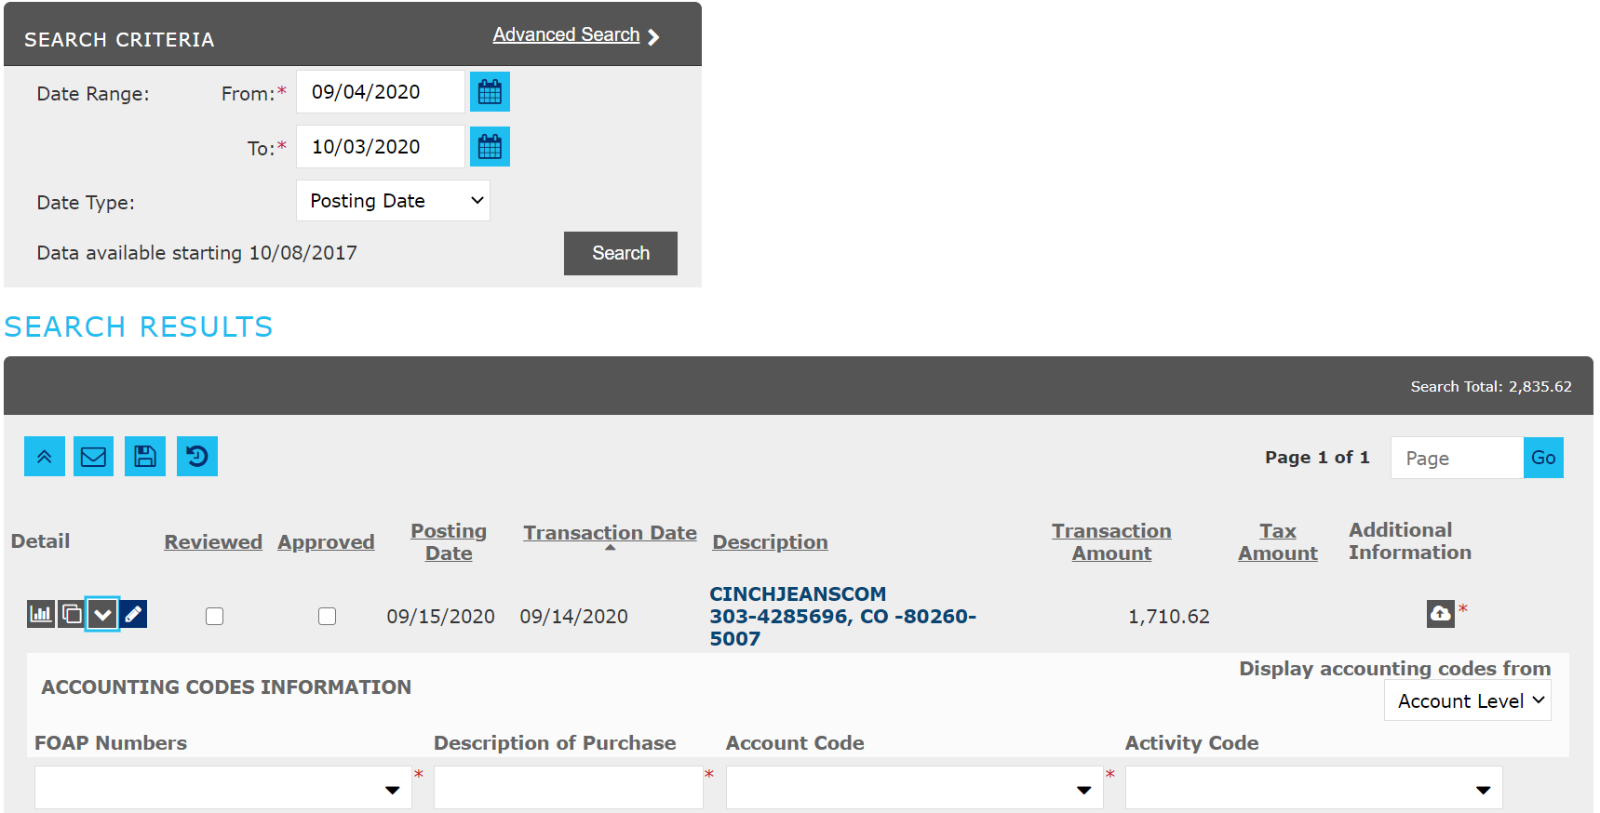

For each transaction enter the required information marked with an asterick *

FOAP Numbers* Click the drop down arrow to select the FOAP Number.

Description Purchase* Type a brief description of the item(s) you have purchased.

Account Code* Click the drop down arrow to select the expense Account code.

Activity Code Optional field; Select SRSUCV if COVID related expense.  
Receipt* Click on the Add Receipt Icon  to attach the expense receipt.

7. Click on the “Accounting Detail” arrow  for each transcation to enter the required information and the applicable receipt.   
  
8. If there are expenses that require allocation between different FOAPS and/or Account Codes please proceed to Steps for Splitting Transactions. If not, once you have entered the required information for each transaction place a check mark inside the box in the “Reviewed” column next to the expense. Press Save and move to the steps for Downloading Report

**Splitting/Unsplitting Transactions:**

1. If the Search Results include transactions that appear to be split by amounts, this means that the merchant has opted for the expense to be split based on what was purchased and the itemization of the receipt.

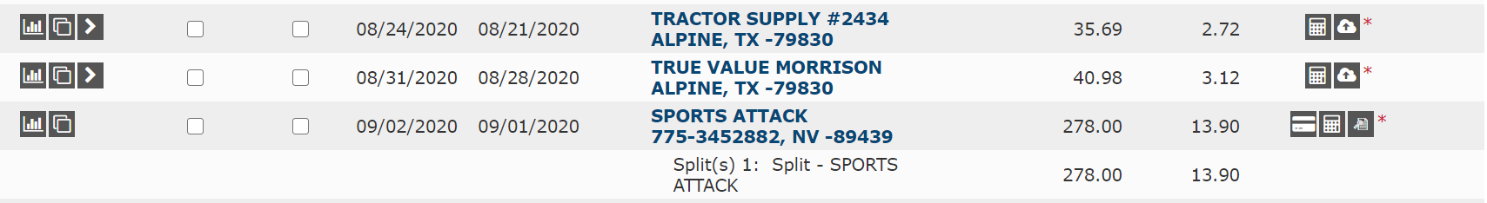

1. You can un-split the transaction so it doesn’t appear to split the expense by clicking the  icon next to the expense. This action will open the Split Transaction screen.

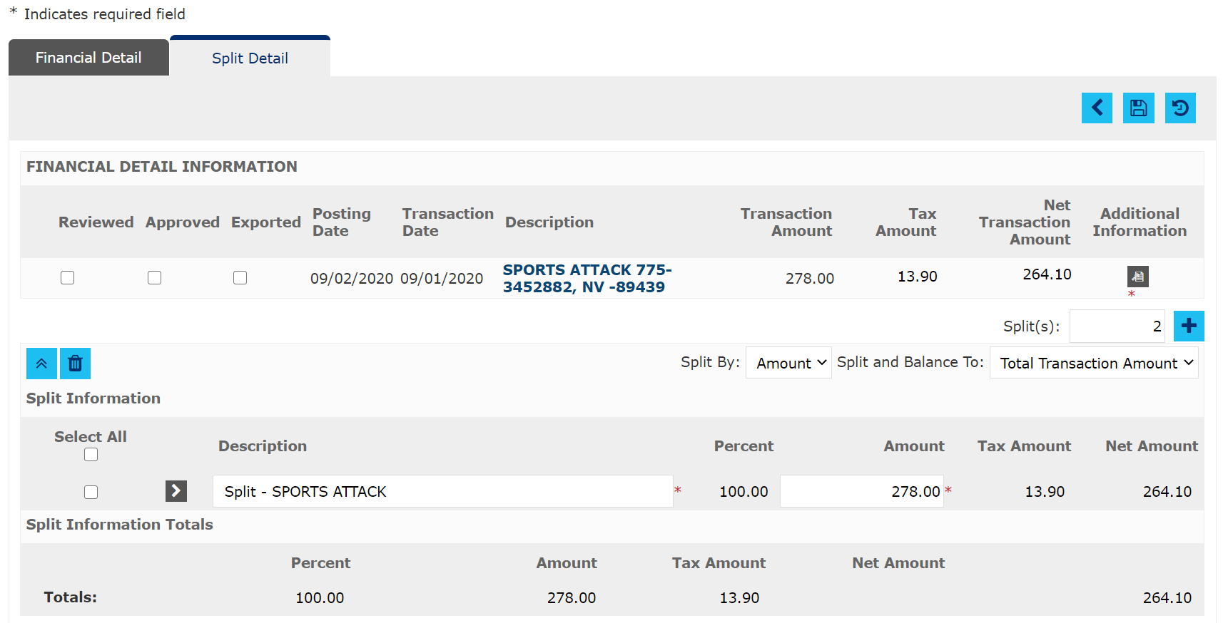

1. Place a check mark in box below “Select All” and click the Remove Selected Split button  to remove/delete the split. Click “Save”  to save the changes made.

1. Click on the Transaction Summary Link to go back to the Transactions Summary Page

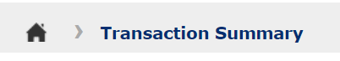

1. If the expense includes multiple items that need to be coded using a different FOAP Number and/or Account Code, Select the Split Transaction button  next to the expense.
2. This action will open the Split Transaction screen.

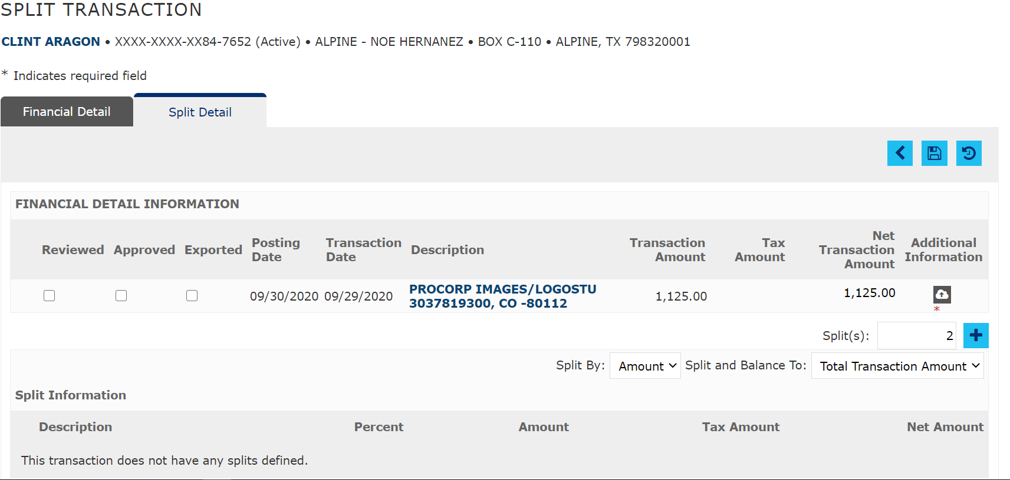

1. Enter the Number of Splits needed for the transaction in the “Splits” field. Press Add Splits 
2. Make sure the receipt for the charge is attached and press Save 
3. 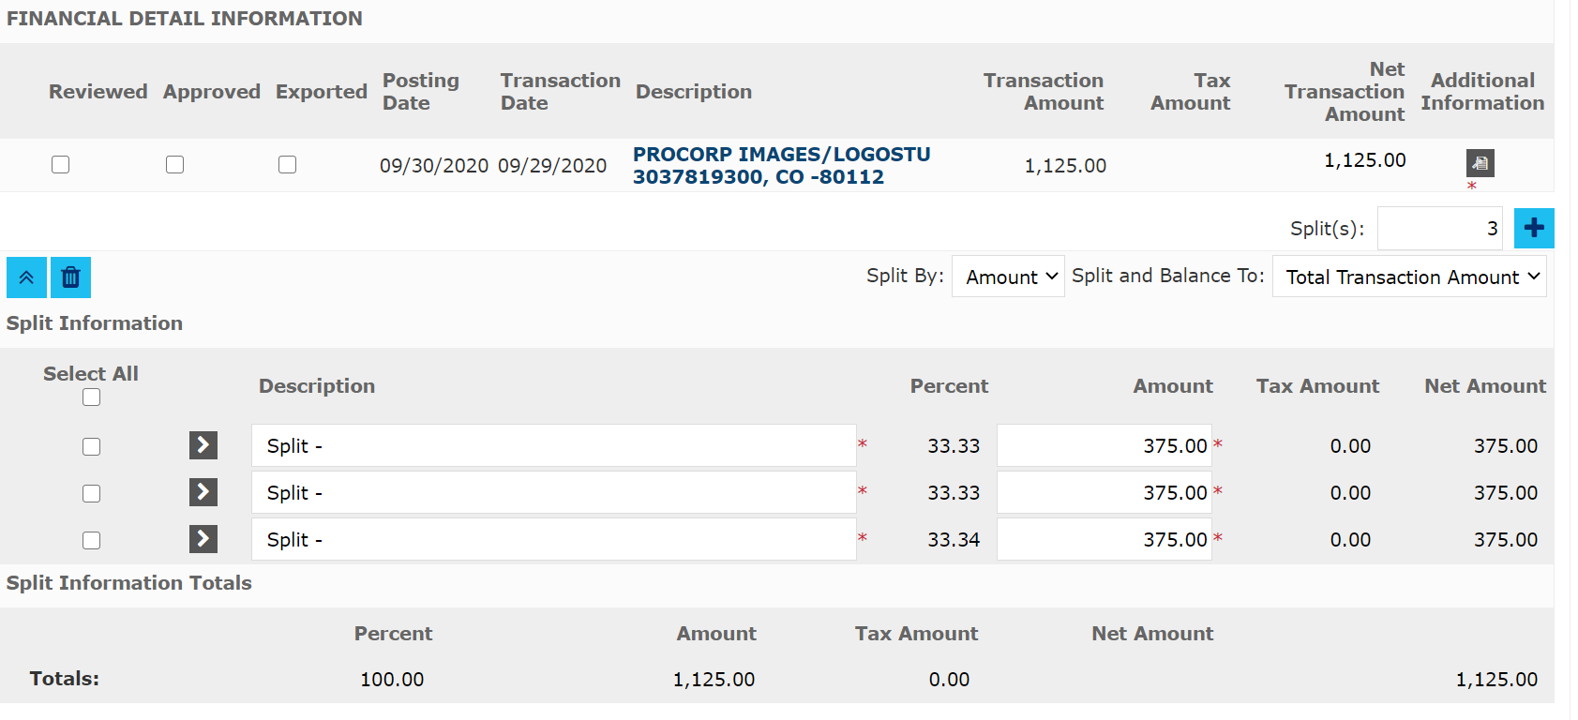The system will automatically split the transaction and total amount according to the number of splits you entered. Additional fields will appear for you to enter a specific description and amounts for each line item
4. Click on the arrow  next to each split to enter FOAP, Description of Purchase and Account Code information.
5. Once you have entered the correct information in each field, place a check mark in the “Reviewed” box to confirm that you have reviewed the information entered for each transaction. Press Save . This will lock the expense and no additional changes can be made.
6. Click on the Transaction Summary Link at the top of the to go back to the Transactions Summary Page
7. Once ALL transactions have been allocated, and the reviewed box is check, click on the disk icon to Save the information.
8. Make sure to save the work so that no data is lost. Once the transactions are saved it is locked to prevent further editing so make sure the information entered is correct before saving.

**Downloading an Expense Report**

1. Once the expense allocation has been saved, access the Reports Tab at the top of the screen and Select “Run”.

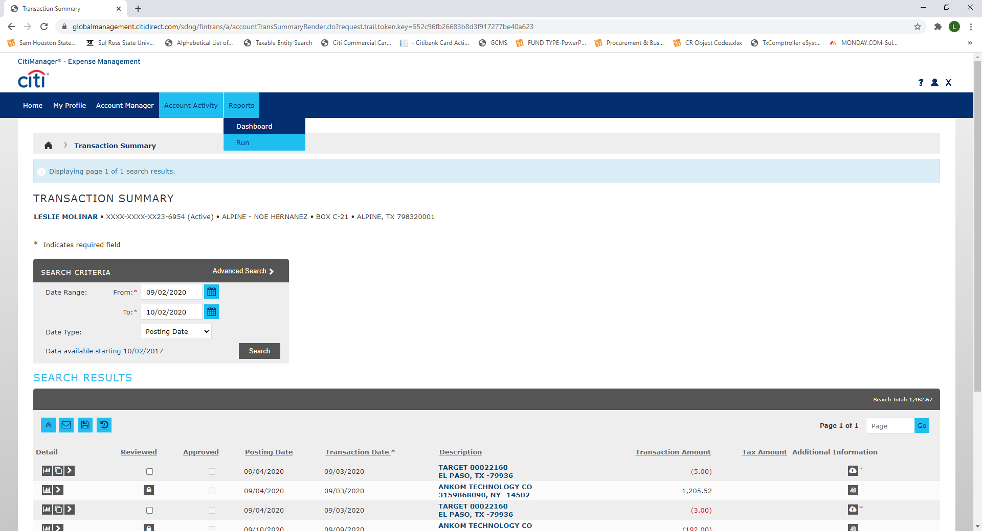

1. A Run Report Screen will be displayed with fields numbered from 1-2.

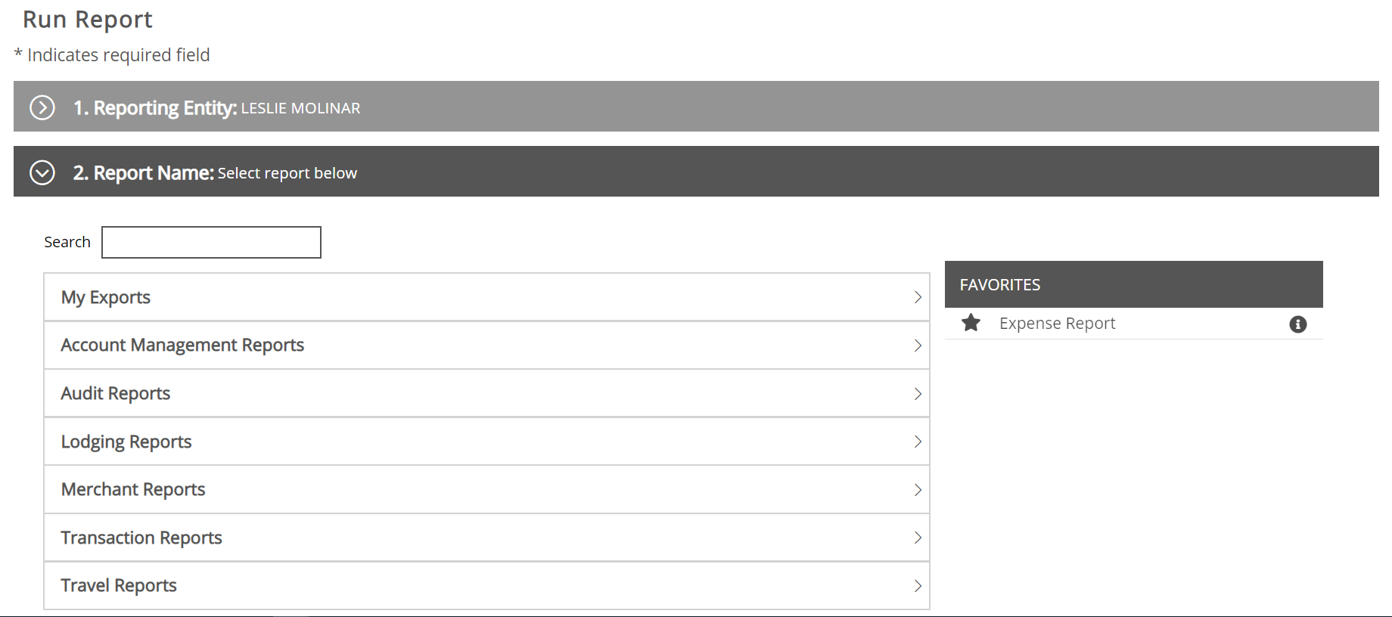

1. Section # 1 titled “Reporting Entity” will display the cardholders name
2. 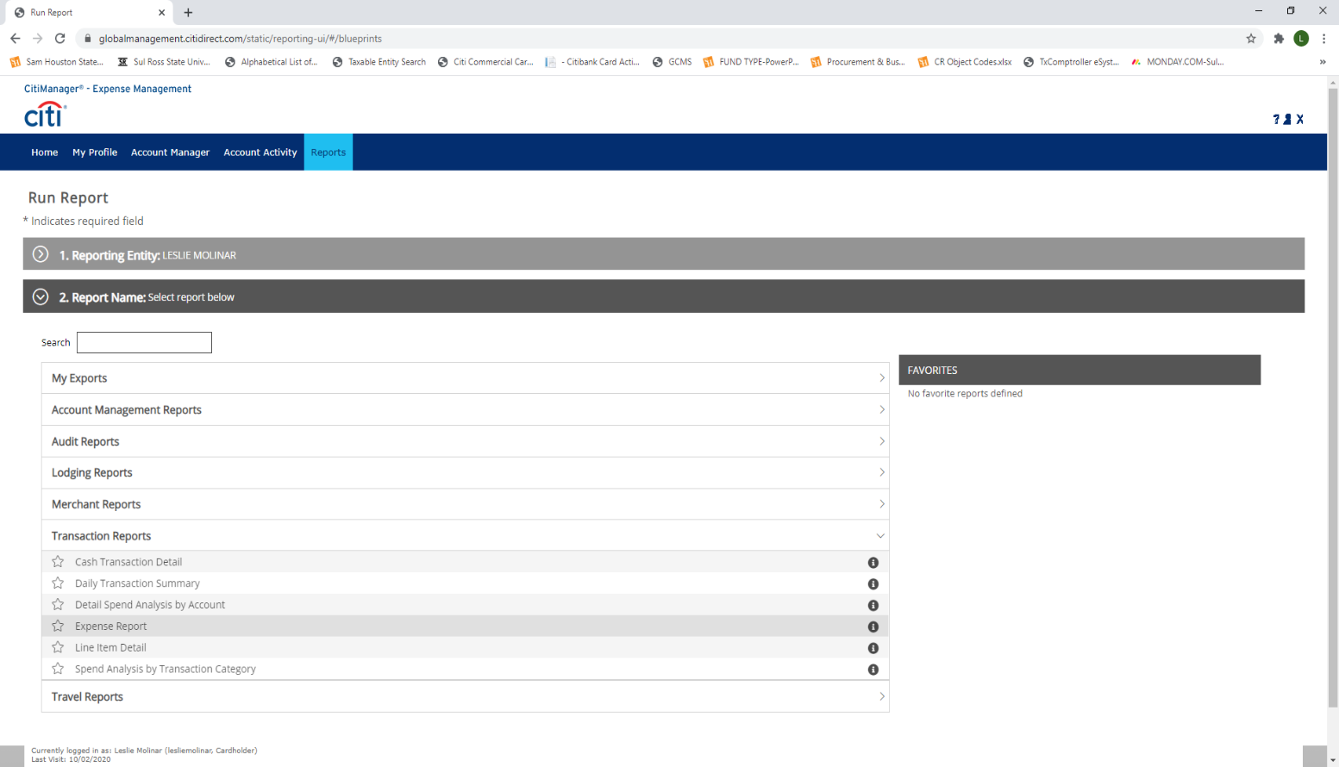Section #2 titled “Report Name” select Transaction Reports and then click on the star next to Expense Report
3. 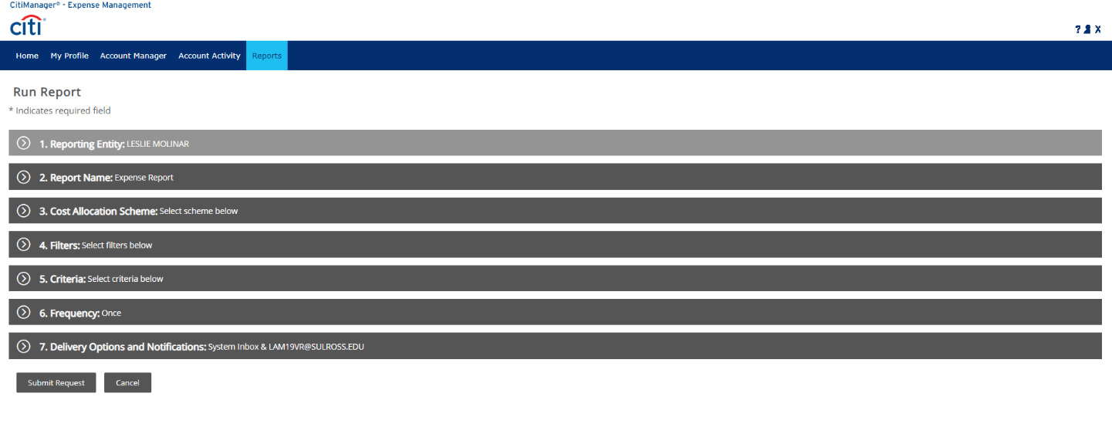The Run Report screen will be displayed with additional Options/filters to assign to your report.
4. Under Section #4 titled “Filters” click on the drop down arrow next to the filter field and select “Reviewed Status”.

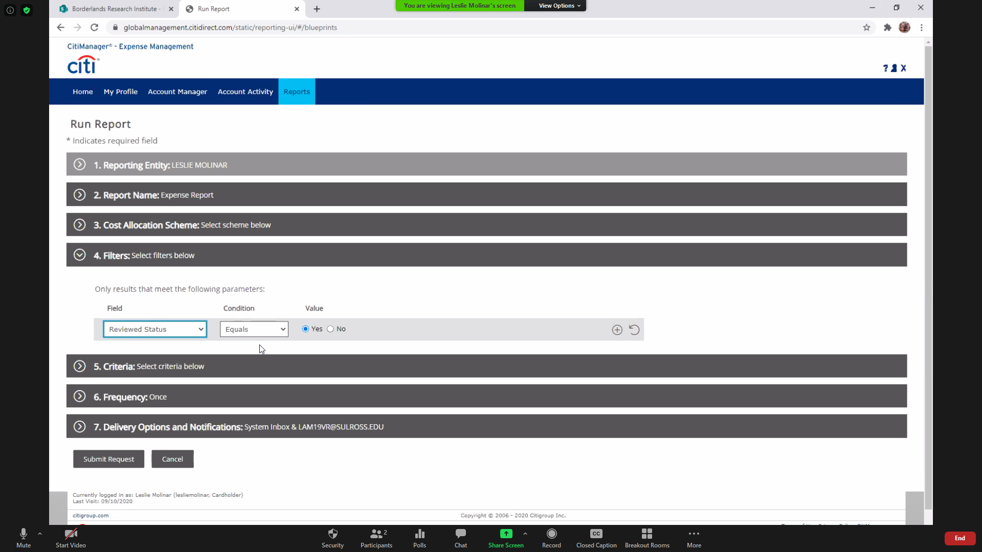

Condition field should be Equals; Value field should be marked “Yes”

1. 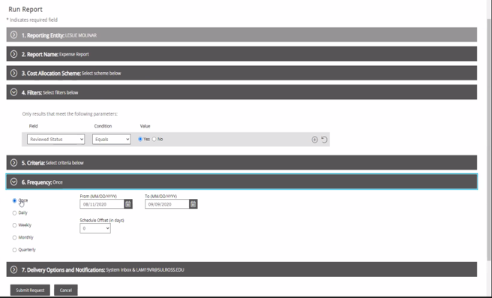Section #6 titled “Frequency” Leave the Once box checked and adjust the From and To Dates to the start and end dates of the current cycle dates (i.e. 8/4/2020 – 9/3/2020)

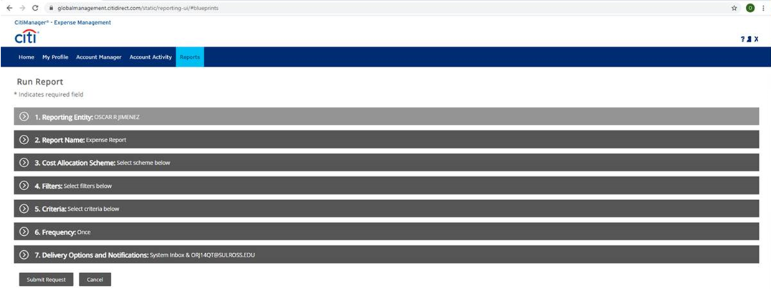

1. Click Submit Request to save and run the expense report. *(Please allow atleast 5 minutes for the expense report to process.)*
2. 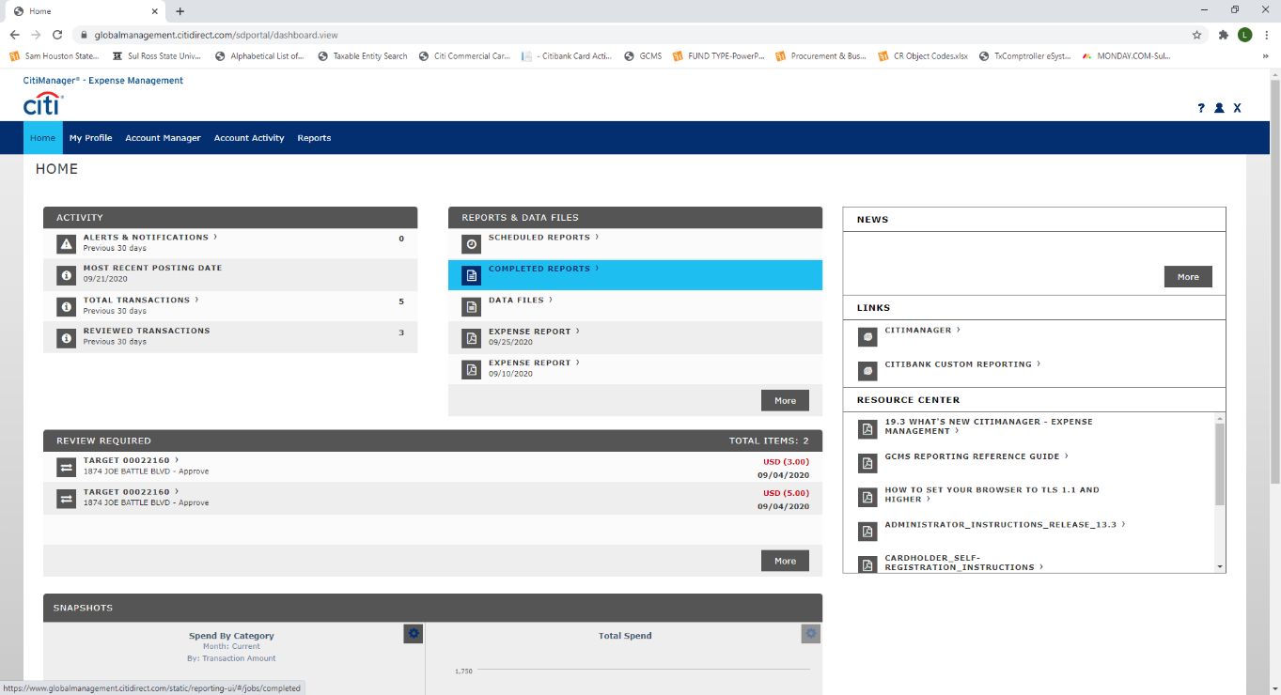When the report download is complete, go to the Home tab to access the “completed reports” section.
3. Click on **Completed Reports to** open your report. Select “**Download”** to open your report in Adobe Reader.

This report should look similar to the example below.

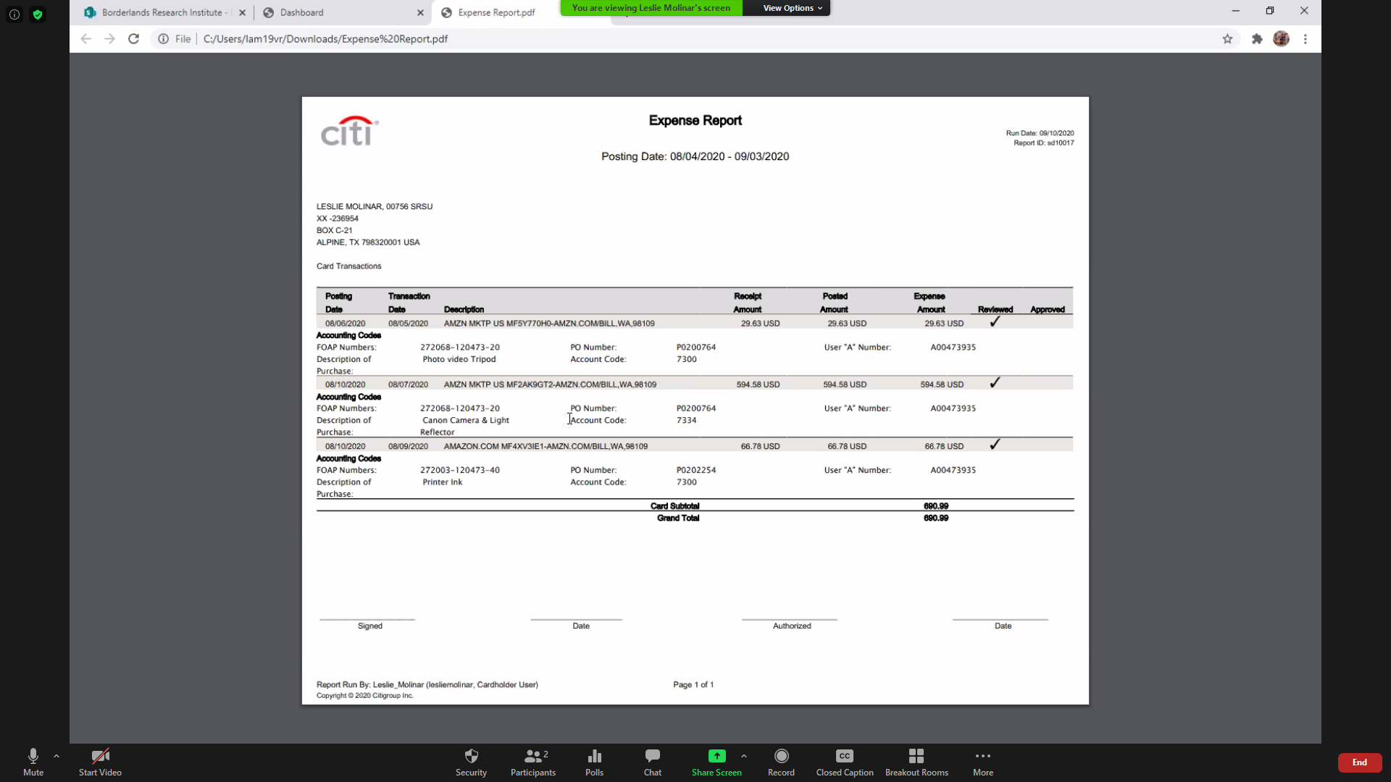

1. **Cardholder will print the report with receipts; sign and date in the area marked “Signed” on the last page of the report.**
2. **Provide a copy of the signed report to your Account Manager/Department Head. Account Manager/Department Head must review for accuracy; sign and date in the area marked “Authorized” on the last page of the report.**
3. **Scan a copy of the pdf report with receipts and any other supporting documentation to** [**srsupcard@shsu.edu**](mailto:srsupcard@shsu.edu)**.**